|  |
| --- |
| LatentView Analytics |
| Response to RFP |
|  |
|  |
|  |
| **10/01/2018** |

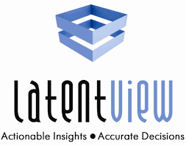

**www.LatentView.com**

| Princeton | San Jose |  Seattle |  Chennai  | London |

| Amsterdam | Singapore |

Table of Contents

1.0 Executive Summary 5

1.1 Context 5

1.2 LatentView Overview 5

1.3 LatentView Credentials 5

1.3.1 Experienced Digital Analytics Player 5

1.3.2 Client Focus 6

1.3.3 Servicing powered through Solutions 6

1.3.4 Advanced Cloud Technology & Visualization Player 6

1.3.5 AI, Deep Learning and Machine Learning Expertise 6

1.3.6 Business Focused Data Architecture 6

1.4 LatentView Solution Approach 7

1.5 Key Differentiators 7

2.0 RFP Background 8

2.1 Background 8

2.2 Scope 8

2.3 Expectations On LEGO’s Support 9

3.0 LatentView’s Key Capabilities in Data Engineering 10

3.1 Building Business Focused Work Load Centric Data Architecture 11

3.2 Bridging New Age & Legacy Technologies 12

3.3 Big Data Capabilities for Enabling Rapid Data Driven Experimentation 13

3.4 Framework For At Scale Processing 15

3.5 Advanced Analytics For Building Scalable AI / ML 17

3.6 Experience in Data Engineering Tools 18

3.6.1 AWS Based Tools and Services 18

3.6.2 Spark 19

3.6.3 Scala 19

3.6.4 KYLO – Apache NIFI 20

3.6.5 Cloudera 20

3.7 Data Science Capabilities 20

4.0 Data Engineering - Case Studies 22

4.1 Case Study – I: Recommendation System To Increase Share of Wallet 22

4.1.1 Business Context 22

4.1.2 LatentView Solution 22

4.1.3 Results & Benefits 24

4.2 Case Study – II: Market Trends from Transactional Data 25

4.2.1 Business Context 25

4.2.2 LatentView Solution 26

4.2.3 Results & Business Benefits 28

4.3 Case Study – III: Risk Identification Using Behavior Modeling 29

4.3.1 Business Context 29

4.3.2 LatentView Solution 30

4.3.3 Results & Business Benefits 31

4.4 Case Study IV – Digital Metrics Tracking 33

4.4.1 Business Context 33

4.4.2 LatentView Solution 34

4.4.3 Results & Business Benefits 36

5.0 LatentView Solution Approach for LEGO 37

6.0 Engagement Model For LEGO 38

6.1 Resourcing 38

6.1.1 Location 38

6.1.2 Resource Deployment 38

6.1.3 Resource Movement & Handovers 38

6.2 Operations 39

6.2.1 Onsite Activities 39

6.2.2 Offshore Activities 39

6.2.3 Time Zone Management 39

6.3 Code Versioning 39

6.4 Transition 39

6.5 Agile Methodology & Experience 40

6.5.1 Methodology 40

6.5.2 Tools to Enable Agile Development 42

6.5.3 Agile Development of Reporting Platform 42

6.6 Global Delivery Experience 42

6.6.1 Building CoE Partnerships – Advantages with Pure Play Analytics Partners 43

6.6.2 Case in Point 43

6.7 Experience in Handling Development on systems in compliance with GDPR & Data Security Policy 44

7.0 Commercials 46

7.1 Resource Skill Set 46

7.2 Pricing for the PoC 47

7.2.1 Assumptions 47

8.0 Data Science Case Studies 49

8.1 Case Study I: Early Warning System (EWS) for Networking Company 49

8.1.1 Business Context 49

8.1.2 LatentView Solution 49

8.1.3 Results & Benefits 50

8.2 Case Study II: Media Mix Modeling for Spend Optimization 51

8.3 Case Study III: Forecasting of Games Sales 52

9.0 LatentView Overview 53

9.1 About LatentView 53

9.2 How are we different 54

9.3 Our Achievements 55

9.4 Our Partnerships 56

9.4.1 Analytics Technology Partnerships 56

9.4.2 Academic Collaboration 56

9.5 People Development at LatentView 57

9.6 LatentView Operating Model & Processes 59

9.6.1 Engagement & Governance 59

9.6.2 Knowledge Management Strategy 64

9.6.3 Knowledge Transfer & Documentation 67

9.6.4 Risk Management 67

9.6.5 Quality Assurance 69

9.7 Data Security & GDPR 71

9.7.1 Data Security Policy - Detailed 72

9.7.2 GDPR 74

9.7.3 Security Certifications 74

9.7.4 Security Training 75

9.7.5 References 76

9.7.6 Experience in Devloping Systems with GDPR Compliance 77

9.8 Key clients supported & powered by LatentView`s Analytics services 77

# Executive Summary

We would like to thank LEGO for inviting us to participate in the data engineering partner evaluation RFP thereby providing us with the opportunity to support their data engineering and business groups and in general LEGO on various facets of data engineering.

* 1. Context

LEGO’s big data capabilities initiative to become a data driven organization faces challenges in the data engineering phase and an external partner can bring in the required expertise and skills to remove the hurdles and accelerate the initiative. For 2018, the focus is on getting the underlying platforms operational and optimize the processes. Development of analytics solutions and specific use cases are next in pipeline.

LEGO would like to evaluate the partner’s capabilities to solve both their current bottlenecks in ingestion and publication stage and also the long-term potential to enable analytics use cases on the new age platforms.

* 1. LatentView Overview

As a strategic analytics partner to several Fortune 500 clients, LatentView has been successful in multitude of strategic digital marketing implementations across industries & markets. The strength & success of these engagements are based on strong collaboration for the development of solutions and services that enable our clients to focus on their core business, launch products, and achieve sustainable growth in new markets and additional channels.

At the heart of our solution designs are scalable technology, a global network of delivery locations which provide elasticity and resilience, deep process expertise, and most importantly a customer-focused and frictionless service integration. LatentView is energized by an enthusiastic and passionate team that pushes for continuous improvement of experiences for its clients and their end consumers.

With this experience & motivation, we strongly believe that we are uniquely positioned to support LEGO over and above the expectations of the current defined requirements.

* 1. LatentView Credentials

As our value proposition to deliver the services required by LEGO (as outlined in the RFP), We would like to highlight the following credentials that will strengthen our case as LEGO’s vendor of choice for this implementation

* + 1. Experienced Digital Analytics Player

LatentView has vast experience working across the breadth of digital analytics and has helped various Fortune 500 companies like PepsiCo, Microsoft, eBay, Standard Life Investments and PayPal in their digital transformation journey. Our analytics offerings for these clients include Brand trends, sentiment, perception and competitor analysis, brand positioning, digital metrics tracking on owned and paid sites, new product introductions, website performance measurement and optimization, A/B testing etc. As a testimony to our expertise in digital analytics Microsoft accredited LatentView as its Gold Certified Partner of choice for digital analytics implementations.

* + 1. Client Focus

Our motto to be “trusted business analytics partner” to our clients drives us to keep a sharp business value creation focus in all our implementations. Having the right mix of people in the team with equal focus on business and analytics skills, knowledge sharing sessions that enable cross-pollination of ideas among teams, constant self-paced learning motivations are some of the employee driven initiatives that drive this focus. In addition, LatentView’s in-house innovation lab and partnership with academic institutions such as IIT-Madras on research areas are primarily aimed at providing the best value to our clients

* + 1. Servicing powered through Solutions

Our deep & vast experience in multiple facets of analytics has enabled us to automate processes and create solution frameworks that allows as to readily implement for our clients with little customization. This in addition to the great gains in the operational efficiency allows us with faster time to market of our solutions compared to traditional servicing models. These solutions also carry the USPs of our best in class technical and analytical architecture that provide great value to the clients on implementation. DigiView, Limerick, TurfView, APT, Amplifyr etc are some of the specialized reusable solutions that LatentView has developed in the field of digital marketing analytics.

* + 1. Advanced Cloud Technology & Visualization Player

LatentView has very rich experience working and implementing various cloud based solutions. We have very deep expertise working with various cloud products and suites offered by platforms like Amazon Web Services, Microsoft Azure and Google cloud. We have over the years also developed excellent skills as a company in building visualizations of the highest standards using tools like Tableau, Microsoft Power BI, D3.js etc that serve up to the CxOs’ of our client organizations. We have advanced networking partnerships with both AWS and Azure and an alliance partner for Tableau – a testament to our capabilities in this area.

* + 1. AI, Deep Learning and Machine Learning Expertise

Being a pure-play analytics player, at LatentView we constantly strive to be the best when it comes to serving our clients with analytics solutions. To this effect, we have developed very deep knowledge and understanding of various AI and ML algorithms like Neural Networks, Random Forest, GBM etc which power most of our text and classification solution frameworks that lie in the heart of our various digital analytics implementations.

* + 1. Business Focused Data Architecture

From our experience with clients across industries and functional areas, we realize that there exists a significant gap between what the IT world offers and what the business wants thus hindering data driven decision making. LatentView recommends and engineers a business focused architecture for its clients to deliver the functional use cases for data driven decision making.

* 1. LatentView Solution Approach

LatentView proposes to deploy 2 data engineers in an onsite – offshore resourcing model to work in a collaborative fashion for the duration of the POC. One data scientist based out of LatentView offices in Chennai will also be available for the duration of the project. The data engineering resources will use the solution approach as outlined below

Figure 1: LatentView’s Solution Approach for LEGO

* 1. Key Differentiators
* Expertise building business focused data architecture
* Advanced AWS consulting partner
* Experience in engaging directly with business, data engineering & analytics teams
* Focus on problem solving using data and Looking for ‘actionable insights’
* Cross-pollination of Ideas from different verticals

LatentView is excited to participate in this proposal and looks forward to a fair & favorable consideration by LEGO.

# RFP Background

* 1. Background

LEGO is a privately held company based in Billund, Denmark with the philosophy that ‘good quality play’ enriches a child’s life – and lays the foundation for later adult life. The LEGO Group decided to begin building internal Advanced Analytics capabilities during year 2017, and have developed a technology stack to enable scalability to cover all of LEGO’s Big Data Analytics needs. It has become evident that the Ingestion and Processing process is a significant bottleneck that needs to be resolved. In addition, LEGO foresees a bottleneck in the Operations & Maintenance process. Specifically, the Development and Operations stages of work need to become scalable and the LEGO Group recognizes that it might be necessary to liaise with an external partner in order to be efficient and quickly deal with current and coming bottlenecks. In this view LEGO wants to identify a partner to engage on a proof of concept (POC) that will test out the partner’s capabilities for a longer-term partnership.

* 1. Scope

The objective of the POC is to find a solution where we can optimize the data source ingest and publication for core data feeds. LatentView team will be expected to work on the LEGO Big Data Platform along with LEGO Data Engineering team with as many data feeds as possible (as determined during the business requirement gathering phase) and deliver quality feeds in an efficient and fast manner by working alongside LEGO’s Engineering Team.

For the POC phase LatentView will be expected to

1. Familiarize with the running technology stack of LEGO
2. Develop and run a process that can perform ingesting, wrangling and publication according to the requirements of LEGO’s Data Scientists, Data Managers and Data Engineers on LEGO’s Big Data Platform.
3. Also, continuously improve and outline approach for process optimization from ingest to publications; to reduce lead time but without jeopardizing quality or compliance to LEGO standards
4. Invest data scientist hours to showcase LatentView’s capability in analytics by providing guidance on an actual use case
5. Demonstrate capabilities for maintenance and collaboration plus a cultural fit with LEGO’s teams

Upon successful completion of the POC, the project scope will expand to include

1. Supporting LEGO’s Big Data Engineers with maintenance and operations task when Analytics or data ‘products’ are scaled to be used by several hundreds of end-users across the LEGO Group
2. Entire maintenance and operations for specific data products on the LEGO platform
3. Participation in ad hoc ‘projects’ as a plug and play data scientist or data engineer in order to provide staff augmentation when the needs arise across the year. This will require intimate knowledge about LEGO’s Big Data platform (technology stack).
   1. Expectations On LEGO’s Support

LEGO will be expected to prepare and share the business requirements as well as all details about the transform & aggregate steps well in advance, so that focus can be given to the ingest-publication steps where LEGO experiences the most bottlenecks. LEGO should also provide access to documentation and SMEs for familiarization to the LEGO’s technology stack and any analytics data products.

LEGO technical team must provide the access to the technology infrastructure in a timely manner and

setup the required privileges in the environment for us to develop and deploy the data ingestion pipelines. Access to requisite licenses for any third-party tools required may be provided by LEGO or LatentView can procure the same (with LEGO approval) and be reimbursed on actuals

A designated point of contact for the engagement will be provided by LEGO

* The designated Point of Contact (POC) would help in coordinating Knowledge Transfer sessions, access to business teams for business understanding and data queries
* Review of deliverables, project status tracking and resolving queries / issues

Access to LEGO’s SMEs would be important for the LatentView team to familiarize itself with the business and data environment, existing reports, understanding of the systems and processes that LEGO follows.

# LatentView’s Key Capabilities in Data Engineering

LatentView’s key capabilities in data engineering is oriented towards moving clients from traditional data architecture to new age data systems in a structured fashion. LatentView’s data engineering framework is a five-step process with business needs aligned to LatentView capabilities and a feedback mechanism for continuous evaluation and improvement.

Figure 2: LatentView’s Solution Approach for LEGO

**Traditional Data Architecture**

Traditional data architecture is technology-driven approach that provides limited agility and insights for actionable decisions

* Data Architecture not suitable for different data types (ex: unstructured & semi-structured data)
* Lack of understanding of business use cases leads to over / under engineered data infrastructure
* Total Cost of ownership is high and linearly increases with increasing data volumes
* Rigid data models with pre-defined schema and access paths
* Lack of distributed processing that can scale up & scale down

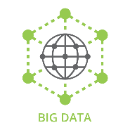

**LatentView Capability:**

Advanced Analytics for Building Scalable AI / ML

**LatentView Capability:**

*Framework for At Scale processing*

**LatentView Capability:**

Big Data Capabilities to enable Data Driven Experimentation

**LatentView Capability:**

*Bridging New Age & Legacy Technologies*

**LatentView Capability:**

Building Business Focused, Work Load Centric Data Architecture

Did we achieve the business objectives with the modernized data systems?

How to bring all the required components together efficiently?

What new capabilities do we need to bring in to achieve the business objectives?

What components (data + tech) from existing landscape should be retained / brought in to the new age systems?

What are the imperatives to move from traditional to modern Data Architecture?

***Step 1***

***Step 2***

***Step 5***

***Step 4***

***Step 3***

**Modern Data Architecture**

Modern Data Architecture address the business demands for speed & agility by enabling firms to quickly find & unify data across hybrid systems

* Ability to handle all data types (unstructured, external)
* Capabilities like Agile data discovery, real-time querying, machine learning workbench
* Timely data through real time streaming ingestion
* Rapid experimentation through sandboxes
* Accountable Infrastructure Management
  1. Building Business Focused Work Load Centric Data Architecture

1. Considerations

LatentView recommends and engineers a business focused architecture for its clients to deliver the functional use cases for data driven decision making. To build Analytics that deliver business value, it requires deep understanding of the following

* Understand People – who, how they make decisions, biases, where they fall short
* Promote Information Usage in Decision Making – Discovery, Brainstorming, Higher order questions
* Business + Data + Math + Technology + Behavioral Skills
* Enable Learning – data labs, experimentation & hypothesis testing, cause-effect modeling
* Worry about solving Business Problems, not just Technology issues

1. LatentView Advantage

From our experience with clients across industries and functional areas, we realize that there exists a significant gap between what the IT world offers and what the business wants thus hindering data driven decision making. LatentView uses a business use case and work load evaluation framework to decide on the appropriate technology for each use case. While there is centralization of data for democratized access, specific technology components for specific use cases are deployed

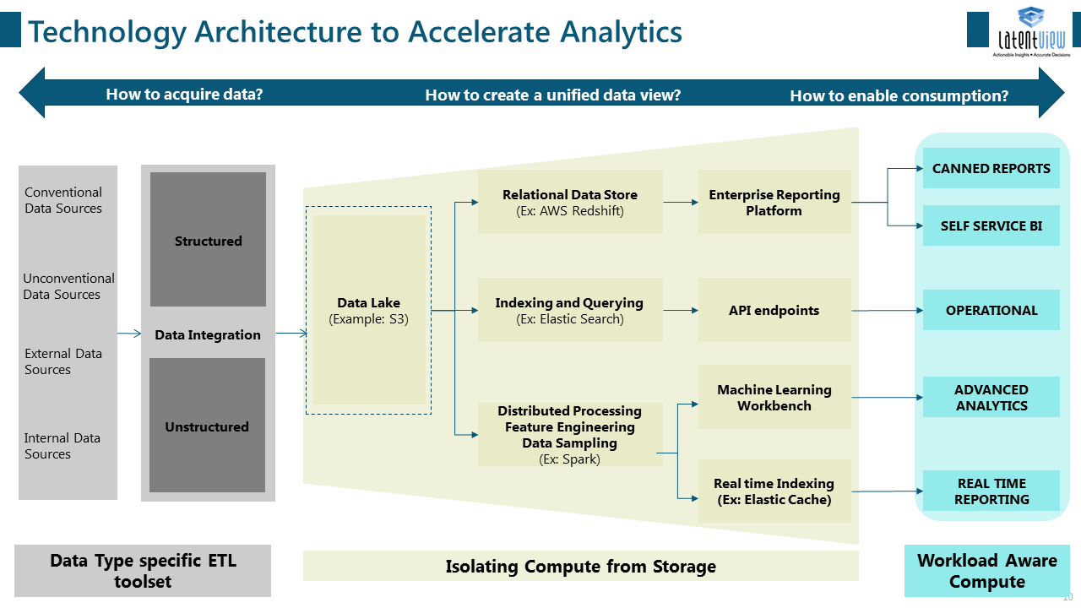

Figure 3: LatentView’s Business Focused Work Load Centric – Technology Framework

|  |  |  |  |  |
| --- | --- | --- | --- | --- |
| Technology | Typical Use Cases | Cost | Performance  Availability  Scalability | Anti-patterns |
| Streaming Ingestion / Transport (e.g. Kafka, AWS Kinesis) | Real-time analytics, log intake/processing  Unified log for enterprise data integration | Low cost of usage, potentially high cost of unmanaged app (e.g. Kafka) | Unlimited scale and performance. Some maintenance overhead for large unmanaged options (e.g. Kafka) | Not for small-scale ingestion – complex tech |
| Event-based processing (e.g. Storm, AWS Lambda) | Real-time or Batch ETL  Event-base processing  Real-time scoring | Low cost of usage for typical scenarios | Exception-based retries, no limits to scaling | Long-running jobs  Apps that don’t require inflight processing |
| NoSQL stores (Cassandra, AWS Dynamo DB) | Semi-structured, Columnar (Cassandra), for fast access and analytics, extremely high scale | Low | Very highly scalable / available with eventual consistency | No complex joins |
| Stream store (Kafka Store, AWS Kinesis Store) | Multiple, parallel consumers (e.g. batch, slow batch, streaming) | Low cost of storage, potentially high cost of unmanaged Kafka | Kafka storage is unlimited. Harder to manage for very large data. AWS Kinesis has 7-day limit on storage | Not for single or few consumers, not for static data (use Hadoop store) |
| Apache Spark (In-Memory) | Interactive Querying small no. of users  Both batch and micro-batch | Low | High performance, works with large datasets, no of spark contexts by size of cluster | Web applications with large no. of users |
| Map-Reduce (PiG, Hive, PoJ MR) | Large-scale ETL  Predictive Modeling | Low cost, based on usage | Fault tolerant through replication, job failures are gracefully handled, highly scalable | Small file processing, small data sets, rapid processing, ACID needs |

Table 1: LatentView’s Work Load Centric Technology Evaluation Framework

* 1. Bridging New Age & Legacy Technologies

1. Considerations

* Bridging new age and legacy technologies can be done in a variety of ways
* 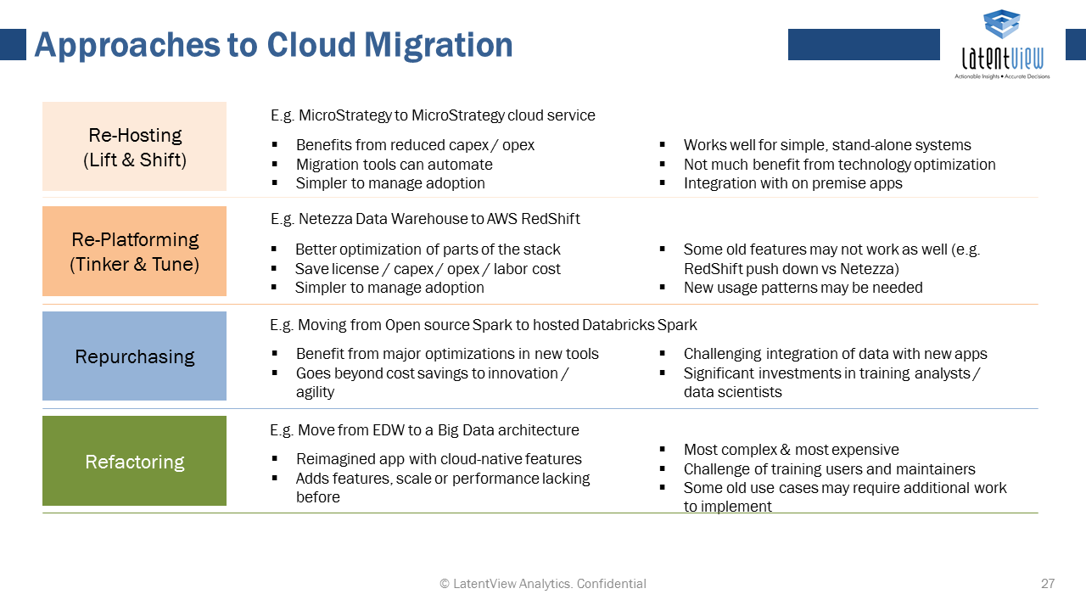

1. LatentView Advantage

LatentView’s global expertise working for established fortune 500 firms like Walmart, Pepsi, Sysco, Sears etc. with several legacy applications, technology giants like Microsoft, Adobe, Cisco, Hitachi etc. and new age companies like Uber, Facebook etc. investing in the most up to date technology provides us deep understanding of both worlds. We have helped several of these fortune 500 firms to integrate data spread across their legacy systems in to a centralized, scalable modern data platform. With the bridging of systems and robust change management framework, LatentView helped drive adoption of their modernized platform.

* 1. Big Data Capabilities for Enabling Rapid Data Driven Experimentation

1. Considerations

LatentView has expertise in handling and integrating data from a wide range of data sources including conventional data like transactional data, traffic data and unconventional data like social media, blogs, forums, data aggregator services, public data sources like world bank, industry specific third-party data sources containing consumer data, household data, competitor data etc. LatentView has expertise in handling in different types of data as listed below

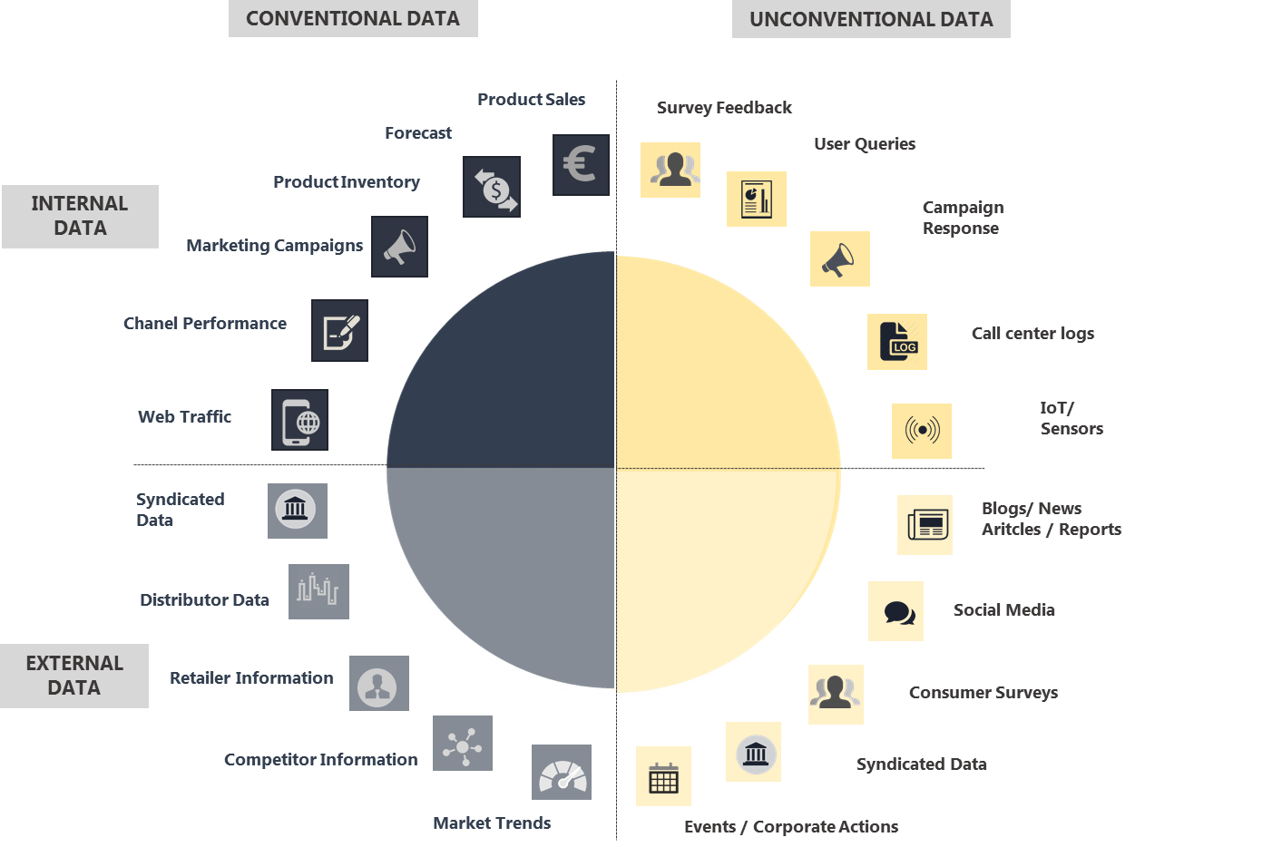

Figure 4: Data Universe for creating 360 degree view of customer

LatentView provides flexible and a scalable framework for Analytics and experimentation on the integrated and machine generated data. This offering can be customized for a wide range of use cases and can be deployed as either a standalone system or can be integrated with customer’s existing IT systems. This on-demand and fast deployment helps organizations be agile in their experimentation and quickly test newer ideas and solutions. The methodology also incorporates CI/CD for productionizing and deployment phase, delivering continuous incremental improvements to the solutions.

1. LatentView Advantage

LatentView has an in-house tool called Amplifyr which is a simple, easy to use, code free analytics platform that aids citizen data scientists, business analysts and decision makers to quickly discover insights from large datasets. Amplifyr breaks down barriers to data analysis by dramatically reducing complexity involved in ingesting and preparing data and exploring relationships within data sets. With Amplifyr, businesses can build ensemble models can easily build ensemble models, visualizations and calculations from disparate data and seamlessly bring these elements together in order to help ask and answer the right questions specific to their use cases. Some typical use cases include predicting future customer behaviour, churn, sales forecasts, and visually compare diagnostics and understand drivers of customer behaviour or risk.

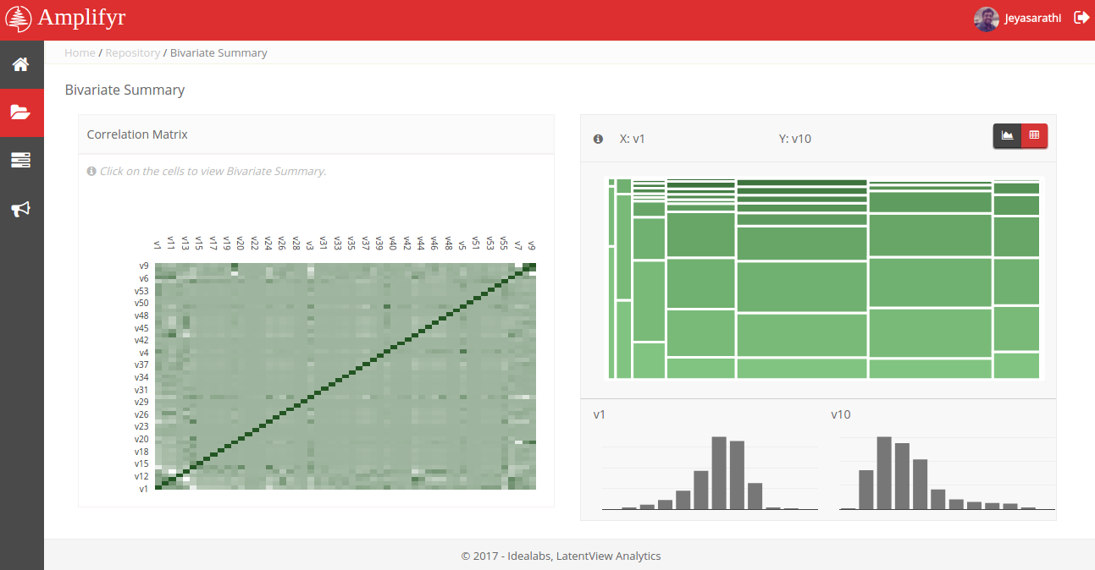

Figure 5: LatentView’s Amplifyr – Exploratory Analysis

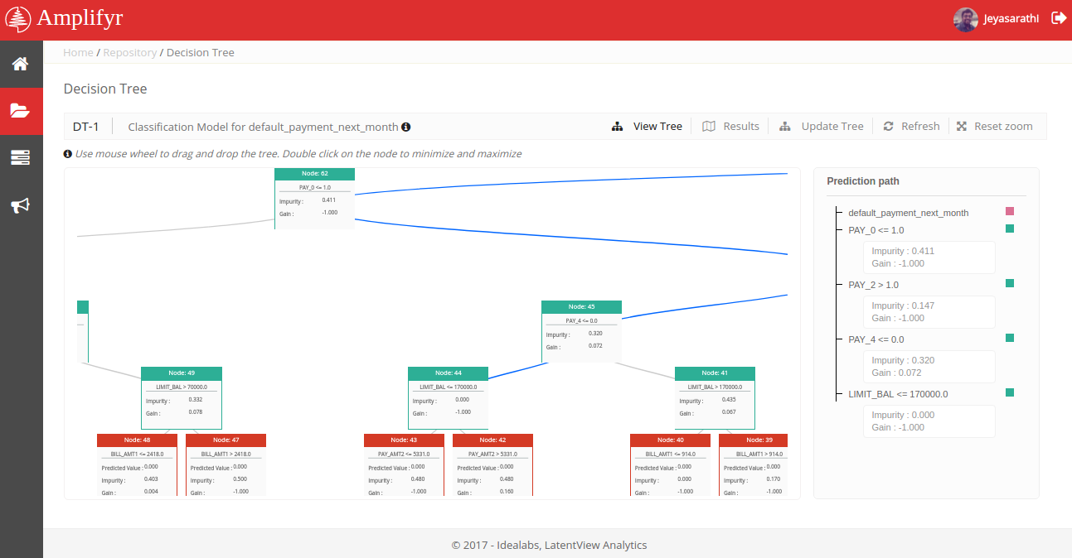

Figure 6: LatentView’s Amplifyr – Decision Tree Model

* 1. Framework For At Scale Processing

1. Considerations

* In our experience, at-scale processing required to bring the data elements together in a modern data platform is best enabled in a cloud based environment. A cloud environment offers a lower TCO, lower time is spent on infrastructure maintenance, ability to focus on new initiatives and projects, more focus on IT Innovation. Cloud environment also provides time-based and event-based scalability, offers replication, data protection and monitoring services with requirements specific platforms at varying service levels (On-demand to dedicated).

1. LatentView Advantage

* As an Advanced Consulting Partner for AWS, the world’s leading Cloud Services provider and Silver Cloud Platform partner to Microsoft Azure, LatentView has the capabilities and expertise to build, deploy, operate and maintain advanced enterprise scale cloud based infrastructure and solutions.

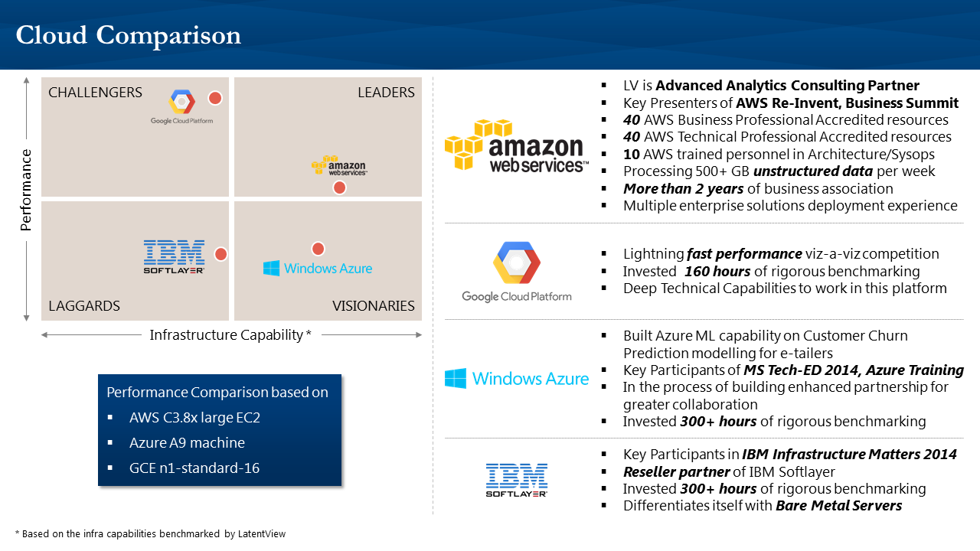

Figure 7: LatentView Cloud Expertise

Our parallel processing cloud framework Banyan helps companies integrate a wide range of data sources efficiently and build a robust data foundation keeping in pace with changing business requirements, growing data volume and variety. This scalable and on-demand framework helps organizations achieve faster time to value, lower TCO, at-will deployment without worrying about infrastructure setup.

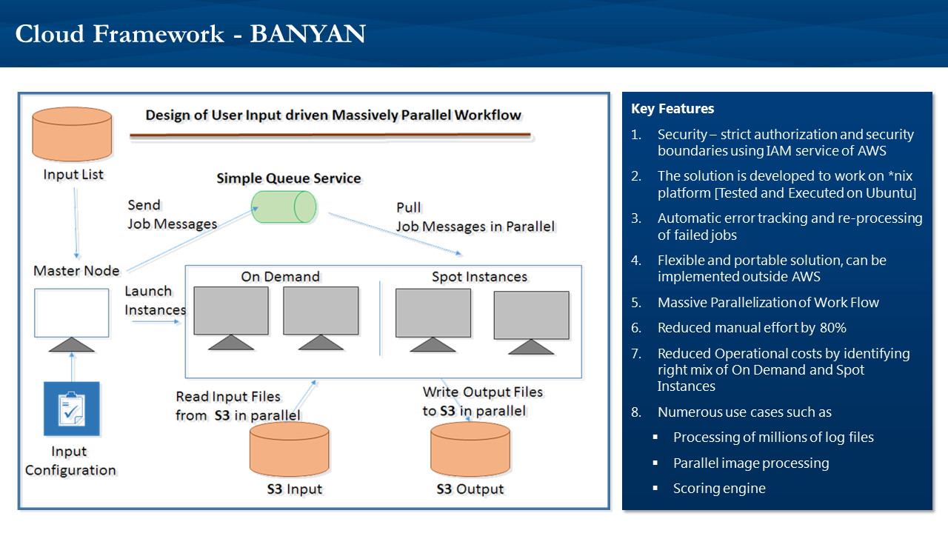

Figure 8: Cloud Framework - Banyan

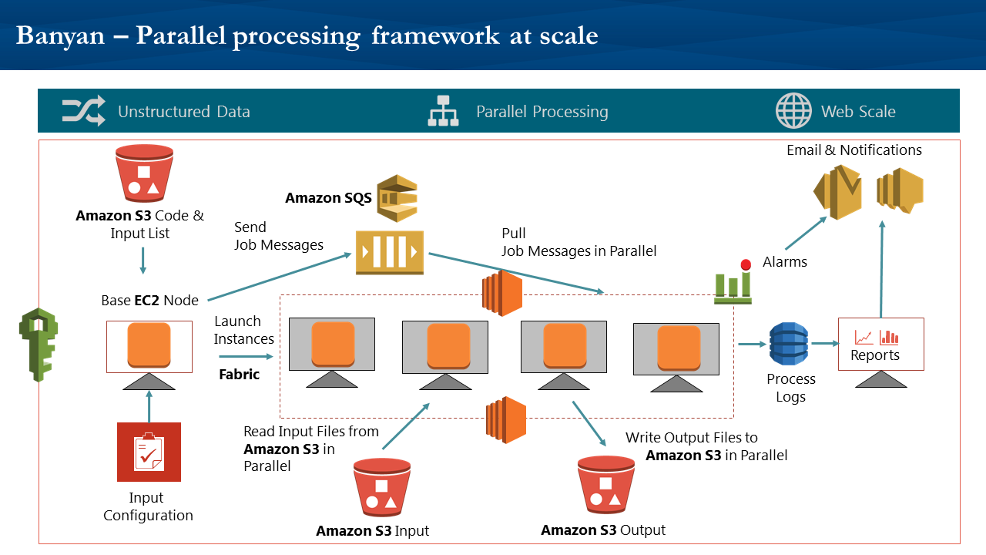

Figure 9: Parallel Processing at Scale

* 1. Advanced Analytics For Building Scalable AI / ML

1. Considerations

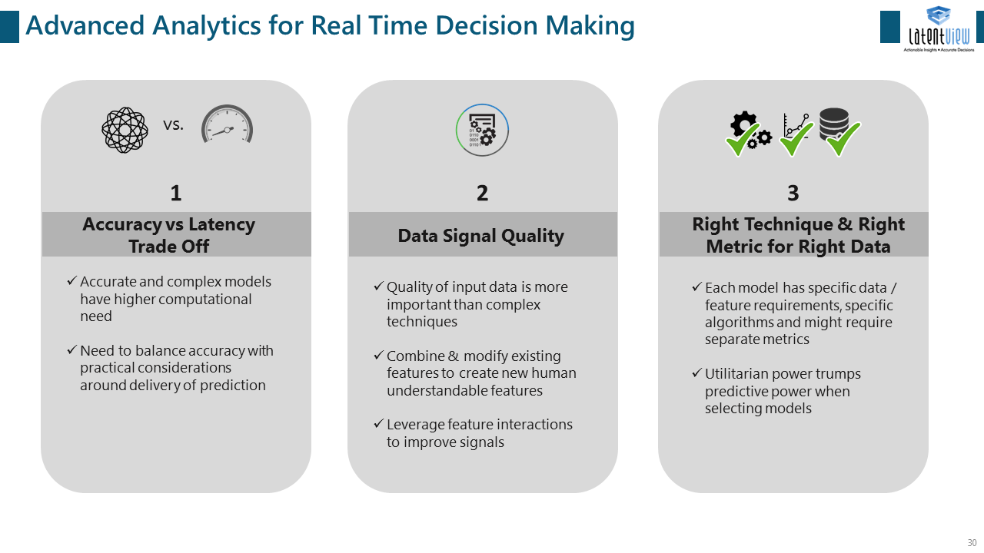

Figure 10: Advanced Analytics for Real Time Decision Making

1. LatentView Advantage:

Being the Microsoft Azure’s Gold Data Partner and Cortana Intelligence Partner, LatentView specializes in building and maintaining scalable AI/ML models in cloud systems.

LatentView Analytics Model Optimization Framework, built using Microsoft’s Azure ML, helps businesses across segments to identify their brands’ key perception metrics and also helps arrive at optimized spending patterns. This model automation framework takes care of things right from the stages of picking up variables for consideration, transforming them and running them through thousands of models to arrive at the one that best suits. It lets you pick a time period for which you want to measure effectiveness of your spends, category of consumers that you are targeting and gives you well packed visually engaging insights reports.

It also takes in all the perception metrics from across categories like geography, segment, form factors etc., and identifies the key ones and also helps you understand the inflection, optimal & saturation points of your spend. The framework is automated end-to-end requiring no manual intervention. It is also completely integrated with Azure SQL for storage and Power BI for reports. Accuracy and reliability have seen massive gains due to this automation, as the entire framework is built on cloud and is completely robust and scalable.

They key highlights of the Model Optimization Framework are

1. Quantifies the impact of the spends
2. Ensures you get the best models for your business rules
3. Makes way for faster business decisions

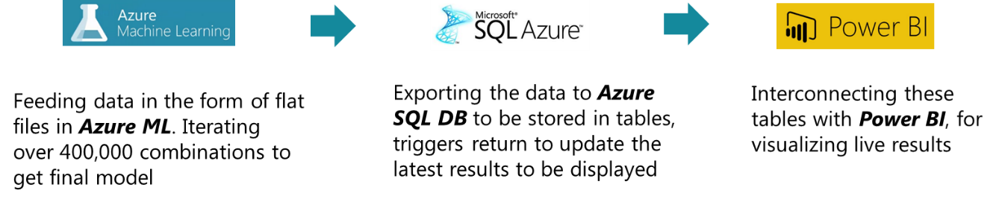

Figure 11: Modeling Automation Framework

* **Minimal manual intervention** – possibility of manual errors reduced significantly
* **Time saving** – Reduced time spent on modelling from ***1 week to 4 hours***
  1. Experience in Data Engineering Tools

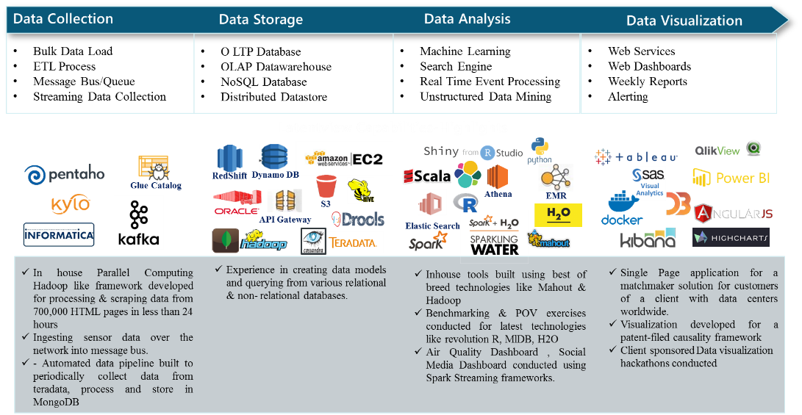

Figure 12: Data Engineering Capabilities

* + 1. AWS Based Tools and Services

1. Overview
   1. Advanced Consulting Partner for AWS

We are an Advanced Consulting Partner of Amazon Web Services owing to great expertise and experience in using AWS cloud platform to develop and deploy analytics solutions.

* 1. Certifications

We are proud to have 5 certified AWS Architects, 40 Technical Professional Accreditations & Business Professional Accreditations

* 1. Innovation & Recognition
* LatentView co-presented Panel Miner solution with AWS at ReInvent 2014
* Indigenous Python based back-end code to for right time data ingestion developed by LatentView called Gravity is now part of AWS standard code
* First ever implementation of AWS Cloud Formation Template for Enterprise level system done by LatentView

1. Projects

* Robust scalable platform AWS Data Lake built using (S3, RedShift, Lambda, Glue, Athena, Dynamo DB, Elastic Search, Cognito etc.) components to access unified data and innovative recommendation engine enabled by Distributed Processing with Spark was architected for a US based food distribution company
* Fully automated daily product catalog for an online travel agent built on AWS infrastructure (S3, EC2) with Python scripts based processing and automation using shell scripting
* PANELMINER a cloud-based, fully-automated, data engineering, exploration, visualization and analytics solution with at-scale data processing using data Hadoop (MapR) on data stored in RedShift (data warehouse) with final visualizations in Tableau. Unstructured data was converted in to structured data using Python prior to data storage in RedShift. The entire solution was built using AWS components S3, EC2 and boto – a python interface to AWS.
  + 1. Spark

1. Overview

* 40+ consultants with expertise across different Spark technologies like Apache Spark, Spark MLLib, Spark SQL, Spark Streaming and PySpark
* LatentView's proprietary Machine Learning platform called "Amplifyr" is developed using Spark & Scala and is utilized in multiple customer engagements
* Ability to work with Spark in a cloud infrastructure (AWS, Databricks etc.)

1. Projects

* Experience is utilizing the Spark platform for data ingesting, preprocessing, querying and machine learning in large scale environments like:
  1. Analyze Purchase Trends in real-time for one of the world's largest Ecommerce marketplaces
  2. Identify driving styles by utilizing sensor data from cars running in 100+ countries
* A real-time dashboard to track social media conversations for a particular brand to gain insights about brand perceptions and comparing with that of other competing brands. Conversations from Twitter Streaming API is consumed from Kafka, parsed & processed to add sentiment of the tweet.
* Real time automated pollution monitoring system from sensor data architected using Apache Spark streaming, search indexing by Kafka on scalable HDFS platform
  + 1. Scala

1. Overview

* 30+ consultants with capabilities to code in Scala
* Extensive experience in inter-operable Java stacks and use of Java libraries within Scala

In memory processing expertise with Scala

1. Projects

LatentView’s in-house tool called Amplifyr which is a simple, easy to use, code free analytics platform that aids business analysts and decision makers to quickly discover insights from large datasets was built using Scala and Spark

* + 1. KYLO – Apache NIFI

1. Overview

Kylo is an open source enterprise-ready data lake management software platform for self-service data ingest and data preparation.

* LatentView has over 200+ person hours of expertise in architecting data pipelines using Kylo
* Data ingestion of over 100+ data sets using Apace NIFI from a variety of data source connections
* Hands on expertise in data wrangling using Hive queries
* Exposure to feed health monitoring and scheduling
* Platform user maintenance using service and entity level authorization features

1. Projects

Built a weather monitoring and forecasting solution by ingesting real-time weather data using an Apache NIFI template and scheduled data feeds for the weather data, using wrangling capabilities prepared the final de-normalized table to enable Hive based querying.

* + 1. Cloudera

1. Overview

* 100+ person Years of experience in working with Hadoop Distributions including Cloudera, Hortonworks, MapR etc.
* Strong expertise in Cloudera components dealing with Ingestion, Storage and Distributed Processing
* Good understanding of Cloudera Manager to monitor large scale environments
* Hands-on experience in utilizing Cloudera Impala for query based processing
* Ability to architect Big Data environments for different workloads, viz. Canned Reporting, Self-Service BI, Querying & Machine Learning

1. Projects

* PANELMINER a cloud-based, fully-automated, data engineering, exploration, visualization and analytics solution with at-scale data processing using data Hadoop (MapR) on data stored in RedShift (data warehouse) with final visualizations in Tableau. Unstructured data was converted in to structured data using Python prior to data storage in RedShift. The entire solution was built using AWS components S3, EC2 and boto – a python interface to AWS.
  1. Data Science Capabilities
* LatentView has helped a number of our clients implement analtyical models that provice significnat business impact. We are tool agnostic, and have experience in developing and deploying analytical models based on techniques such as Linear Regression, Decision Trees, Time Series Forecasting, Optimzation techniques, Neural Networks, Bayesian techniques, etc. We have presented our modeling framework below.

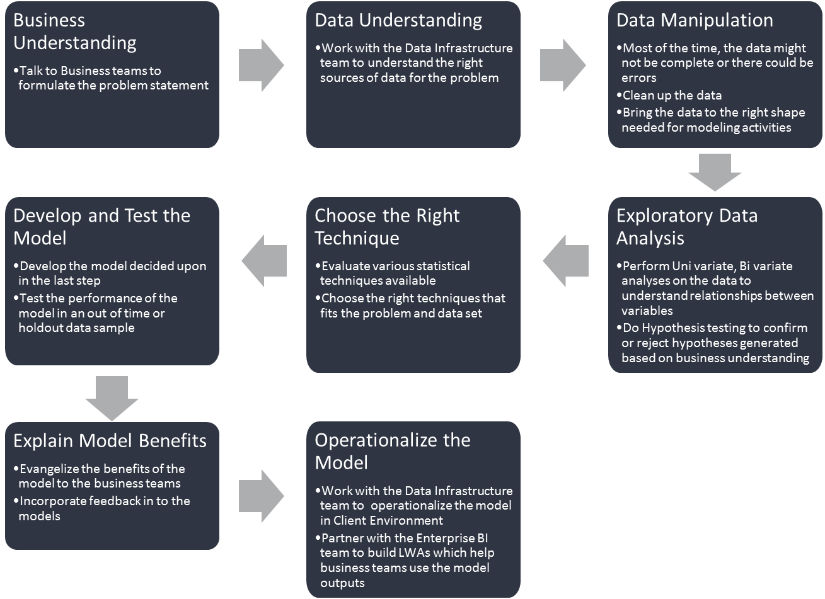

Figure 13: LatentView Analytical Modeling Framework

Key deliverables for an analytical modeling project are:

* **Data Profiling** – a presentation at the end of the analysis phase, summarizing the key findings that emerge from the profiling and analysis.
* **Explanation of key variables** – the key variables that constitute the model and their respective coefficients will be explained.
* **Model performance report** – month-on-month delivery of a report that details the performance of the model.

# Data Engineering - Case Studies

* 1. Case Study – I: Recommendation System To Increase Share of Wallet

|  |  |
| --- | --- |
| Client | The client is the largest food distribution company in the United States |
| Problem | In an industry where customer acquisition is fairly expensive, this company’s repeat orders were at a low 4% |
| Solution | Provided a robust scalable platform to access unified data and demonstrated the use case to improve product discoverability using an innovative recommendation engine that combined customer segmentation, user-based collaborative filtering and market basket analysis |
| Impact | 20% increase in value of new orders from existing customers.  Higher customer satisfaction due to precise recommendations |
| Technologies & Techniques | AWS Data Lake with (S3, RedShift, Lambda, Glue, Athena, Dynamo DB, Elastic Search, Cognito etc.), Distributed Processing with Spark, Hive & R, PySpark, MLLib, D3, Highcharts  Collaborative filtering & Market Basket analysis |
| Operations & Roadmap | LatentView continues to own both the operation and maintenance of the data platform and the client visualization layer. New use cases for the data platform are being evaluated and a detailed roadmap for implementation was prepared |

* + 1. **Business Context**

Client’s legacy systems suffered from a range of issues that affected their business including,

1. No unified view of data
2. Existence of data silos with inadequate documentation leading to data discovery issues
3. Lack of at scale prototyping platform
4. No single version of truth to test multiple analytics use cases
5. Low product discoverability
6. Non-optimal product recommendations and high customer churn

To address the above data and business issues, client wanted to build a unified data system and prototype the critical analytics use case: to improve product discoverability and recommendations. In order to achieve this the following was required.

1. Operational Reporting by field sales managers (Highly concurrent request pattern)
2. API for Data Products – Deal Broker Application, Recommendation Results
3. New metrics development based on Order line level logistics attribution
   * 1. **LatentView Solution**

LatentView worked with client’s data engineering, product, analytics and marketing teams to migrated 60TB of data from legacy systems into a cloud based AWS data lake with extended periodic data refresh which supports reporting and advanced analytics solutions. Using this data lake that offered a unified single version of truth, LatentView setup the data pipeline to analyze the huge volume of sales transactions and identify the possible new items to be recommended for each individual customer to purchase. Business rules such as recommended items should not have been purchased by the individual customer in the past were incorporated and products that frequently co-occur in a basket were identified to strengthen the cross-sell recommendations and prioritizes based on customer value

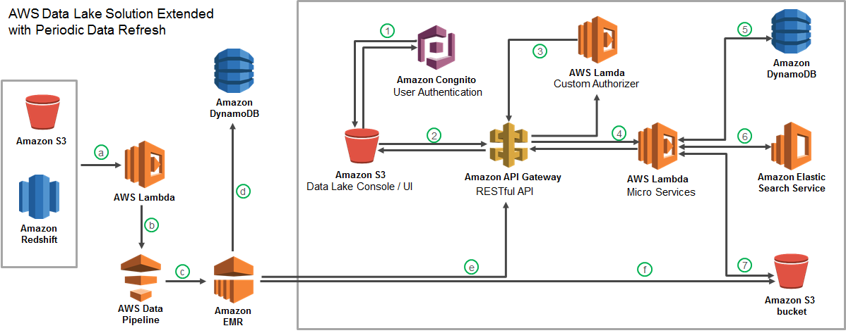

Figure 14: AWS Data Lake Solution

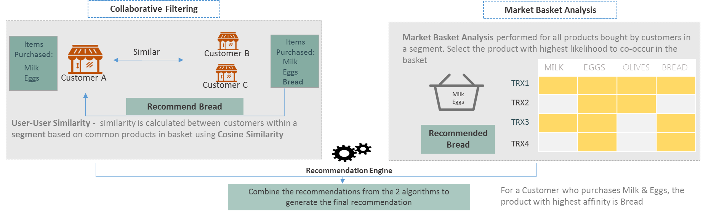

Figure 15: Illustrative Recommendation Engine

1. Challenges

#### Data

* Data grew at a larger scale making it impossible to scale with legacy systems
* Newer data types with high velocity such as truck sensor data could not be handled in existing EDW
* Metadata both business and technical was not searchable hindering product discoverability
* Raw unclean data was not stored in legacy systems thus discouraging experimentation
* Data Storage Constraints due to Total Cost of Storage incurred in existing legacy systems

#### Technical

* Existing legacy systems did not have import options for multiple data types
* Extensive manual option configuration required to ensure ingestion of data in each format
* Netezza system built with periodic reporting as the main use case, does not offer required response time for other use cases like Data APIs

1. Improvements

* Schema free ingestion in to a AWS data lake powered by AWS Cloud Formation Template for Enterprise level system with search capabilities using elastic search
* Indigenous Python based back-end code to for right time data ingestion - Gravity
* At scale prototyping platform for rapid data driven experimentation
* Intelligent query bridge made available in S3
* Optimized Data Storage using Parquet, Gzip, etc.

1. Operations & Maintenance

LatentView continues to operate and maintain both the data platform and the client visualization layer. The routine tasks that LatentView did in the

1. Periodic data and reports refresh as per schedule
2. Validating the published data & transformed data against original data sources
3. Verification of the data processing steps and extending the system to other operating companies
4. Incremental query optimization to improve data ingestion speed
5. Evaluating and performing intended trial analyses for additional use cases
6. Quarterly updation of the user documentation, data structure and data dictionary documents
7. Analyzing utilization patterns/ trends and presented monthly reports on infrastructure usage
8. Forecasting utilization levels and monitoring auto system scaling based on traffic requirements
9. Managing the user access control to the platform by adding and deleting users, setting access levels and controls
10. SLAs

* Data availability in central repository with-in 2 hours of data appearance in source systems
* Weekly refresh of recommendation reports for all 70 operating company sales teams to be available by 7 AM regional time
  + 1. **Results & Benefits**

Workload centric data systems capable of handling multiple Advanced Analytics ML pipelines (Product Recommendation Engine - Already deployed), reporting out of Redshift spectrum, Adhoc analysis in Athena (For Price Migration Tool – In development). All these were made available in a cost-effective manner with automated scaling up/down based on requirement.

Within the first few months of the recommendation engine going live, potential customers were targeted for cross-selling and prioritized using the RFM scores generated for each customer. Real time recommendations and data based insights were provided to the marketing associates, making it easier to sell new products to customers. This effectively led to a 20% increase in value of new orders from existing customers and also drove higher customer satisfaction due to precise recommendations.

* 1. Case Study – II: Market Trends from Transactional Data

|  |  |
| --- | --- |
| Client | The client is a major multi-national e-commerce market place giant |
| Problem | In a highly competitive e-commerce space it is important to keep the interestingness of the marketplace / offerings to enhance customer experience, drive user and transaction growth |
| Solution | LatentView built a real-time platform to visualize market trends, purchase trends, popular items etc. for any search/product term from 4TB of historic transaction data over 3 years with a response time lesser than 1000 ms |
| Impact | 20% of platform users (32% of searches) visited the marketplace website and contributed to a 3% uptick in transactions in select categories |
| Tools, Technologies & Techniques | Apache Hadoop, Apache Knox, Teradata, Kafka, Hive, Elastic Search, Bootstrap, NodeJS, Log Stash, AngularJS, jQuery |
| Operations & Roadmap | LatentView built this as a fully automated system requiring minimal maintenance. The focus of the ongoing engagement was to make incremental improvements, perform monthly maintenance activities, monitor the platform adoption, and ROI |

* + 1. Business Context

With increased competition in the e-commerce space, the client had to come up with interesting value adds for both their buyers and sellers, to reduce churn and improve on user base / transaction growth. Client did not have a common platform which buyers/sellers could use to understand what the popular products were and how they were trending across geographies. However, development and deployment of such a tool is limited by several technical constraints including

1. Ingesting 1.2 TB, 4.5 billion records from legacy systems in to responsive query system
2. The siloed nature of the data across business units required co-ordination and approvals from multiple business stakeholders
3. Security requirements for building an automated data pipeline across various systems is more complex
4. Need for ultrafast response time for queries in the order of 1000 ms
5. Being a multi-national company with presence across geographies, the platform must provide multilingual support
6. The system must be robust enough to work across multiple devices
   * 1. **LatentView Solution**

LatentView built and maintained a search engine using 3 years of transaction data and provided a real-time user query able platform to visualize market trends, purchase trends, popular items etc. for any search/product term and allows comparison between products and product categories.

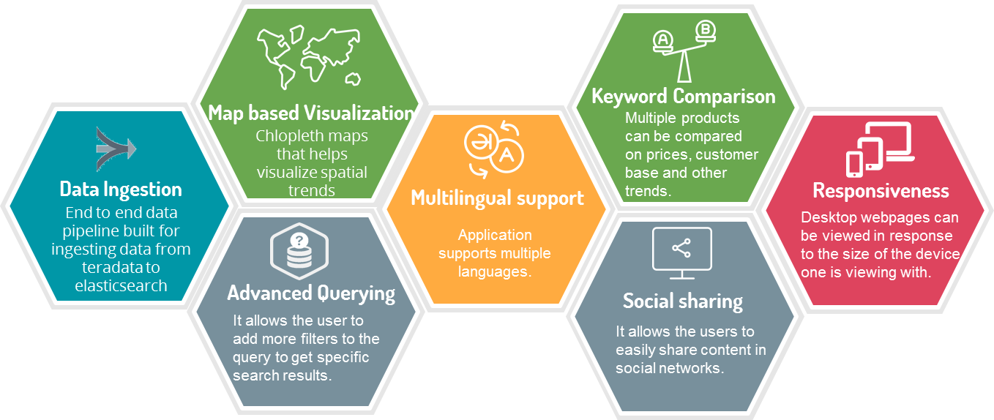

Figure 16: Solution Features

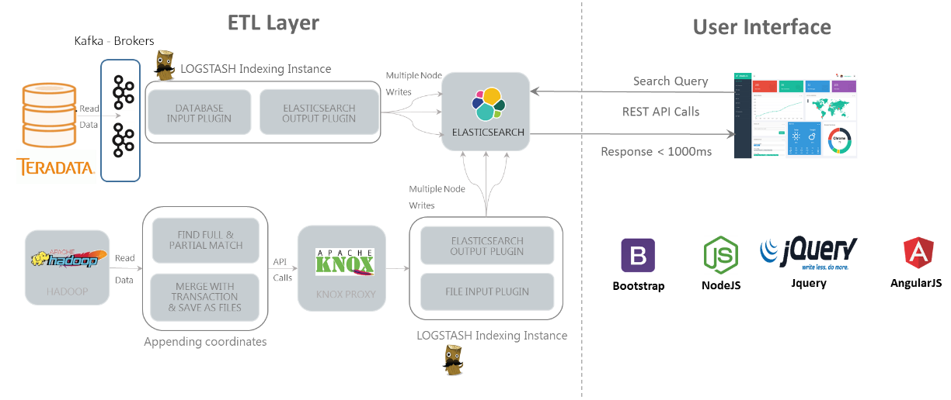

Figure 17: Solution Technical Architecture

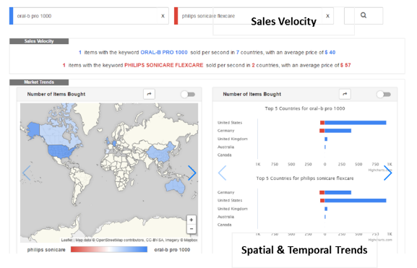 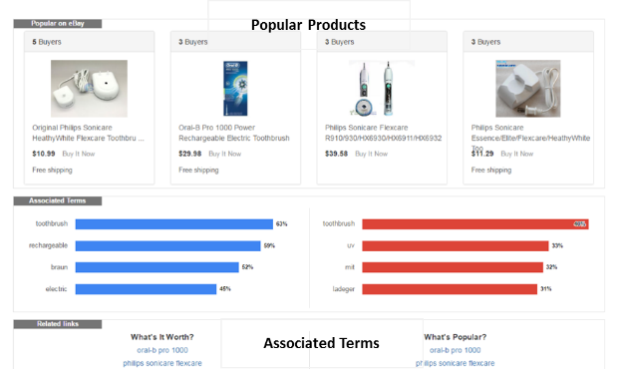

Figure 18: Platform Snapshots

1. Challenges

#### Data

* Data existed in siloed protected environments requiring permissions form multiple business and functional units
* External data was required for the chosen use case can’t be brought in to existing systems
* Multiple data types and formats
* Data existed in multiple languages

#### Technical

* Frequent changes in source data systems (several APIs) in terms of data structure and format
* Elastic search system could flip in production server requiring re-ingestion
* Ultrafast responsive times on massive data query is not possible on Teradata or Hadoop platforms
* Automation Challenges – Connection Failure Handling

1. Improvement Steps

* Setup an exclusive Hadoop architecture for data integration and used specific bridging applications to bring all data together
* For enabling efficient searches on multiple data types advanced queries with several configurations were done in an incremental fashion to ensure continuous data availability
* Alerting system built to notify changes in incoming data format and prompt corrective action
* Memory restrictions in production server to avoid flipping of elastic search
* Ingesting from the integrated Hadoop data platform in to elastic search using Apache KnoxProxy
* Efficient optimized queries on elastic search, proper indexing using log-stash helped achieve the ultrafast <1000ms response
* Asynchronous processing using Node JS was used for responsiveness

1. Operations & Maintenance

LatentView’s solution build approach focused on using the business focused right technology tools specific for the intended use case. For this platform full automation was envisioned at the start of the project and all build steps focused on ensuring that the solution is completely automated. LatentView made weekly maintenance on the application for the first 3 months of the application deployment and then moved to a longer monthly maintenance schedule. LatentView continues to make incremental improvements to solution, evaluates platform usage by the users and periodic monthly maintenance tasks.

The list of monthly maintenance tasks includes,

1. Data volume / number of records verification
2. Data Sampling to ensure data format, consistency etc.
3. Validating data types of ingested data
4. Post processing check
5. Testing of Email alert systems
6. Updating documentation to track changes to system
7. Monitoring Application logs for any anomalies in data ingestion
8. Testing of the platform and processes for responsiveness, accuracy, speed etc.
9. Analyzing utilization patterns/ trends and ensuring optimal infrastructure usage
10. SLAs

* Ensuring query search response time does not exceed 1000ms for 95% of the search queries
* Completely automated system with only monthly maintenance activities
* No more than 3 business days down time of application to fix ingestion failures due to source data changes
* No more than 1 business day downtime for ingestion failures due to technical reasons
  + 1. Results & Business Benefits

The tool helps different user groups and offers them specific and relevant benefits. For sellers and internal users, the tool aids in identifying high potential markets, red ocean markets, markets with high demand but unexplored by rivals etc., so that they can make their strategic business decisions. Product price comparison is another feature that benefits the seller to ensure that they price their products competitively and the buyer to ensure that they get the best price. Sellers also benefit from identifying popular & trending products across brands, and use that information in their inventory management decisions.

To sum up the benefits by the user groups

1. Buyers: Discover the hottest products, average price of products in any given time and place. Will drive more traffic to the site and hence revenue.
2. Sellers: Serves as an intelligence tool helps existing or potential sellers turn transaction data into decisions
3. Internal Users: Self-serving BI tool that can be used to compare trends across products

The new platform led 20% of the platform users to visit the marketplace website and perform 32% product searches which resulted in an overall impact of 3% increase in transaction volumes across key product categories

* 1. Case Study – III: Risk Identification Using Behavior Modeling

|  |  |
| --- | --- |
| Client | The client is a Europe based Iconic Automobile Manufacturer |
| Problem | Costs incurred due to warranty claims had a negative impact of almost 2.5% on the bottom line of the company |
| Solution | Provided a robust scalable platform which modelled customer behaviour using driving patterns & warranty / repair data. This platform enables a user to carry out root cause analysis by correlating driving styles with warranty issues. |
| Impact | Warranty costs reduced by 35% for the “long pause and short trips” driving style due to proactive ‘drive right’ messaging communicated to at-risk drivers |
| Technologies & Techniques | * AWS Databricks, Apache Spark, Mongodb, React, Html, JS, Scala, D3.JS, Spark MLIB * K-means clustering, Random forest, Decision trees |
| Operations & Roadmap | LatentView continues to maintain the platform and the client visualization layer. New use cases for the data platform are being evaluated and a detailed roadmap for the future is being implemented. |

* + 1. Business Context

***Situation***

Client pays for the claims filed by the vehicle owners during the warranty period. Owners file their claims through the car dealers. Client is incurring millions of dollars as cost due to these warranty claims. This cost is directly impacting the company’s bottom line and indirectly impacting the customer perceived quality. The data to solve solutions to this problem is available in Client’s databases.

***Complication***

The available data is huge in volume and has a number of dimensions. If this data could be used then answers to a lot of questions related to warranty cost and driver profiles could be found out. And it is still not clear if there is correlation between warranty cost and driving patterns.

***Key Question***

How can Client make use of the available data to reduce the cost to warranty claims?

***Challenge***

Data flowing in from the car’s controllers are not standard across vehicle and software releases. It was in a format that was unusable for any direct analysis. There were 10 million cars across the globe with different controller versions, numerous engine & motor types, fuel and a list of other dimensions. Data analysis becomes a mounting task. A single manual analysis would take on an average of 30 days and still in most of the cases would not result in an actionable insight.

* + 1. **LatentView Solution**

LatentView developed a self-service and code-free analytics platform that can be used for a wide variety of usecases ranging from simple visualizations like data distribution to complex usecases like driver profiling and defect prediction. Platform consists of an interactive user-interface, machine-learning pipelines and data pipelines.

Data pipelines to periodically convert the incremental sensor data from vehicle controllers into a useable aggregated format were developed. Real time data summaries, model training and scoring is built into the platform to enable the user to uncover driving patterns and run prediction models for different customer segments as and when required.

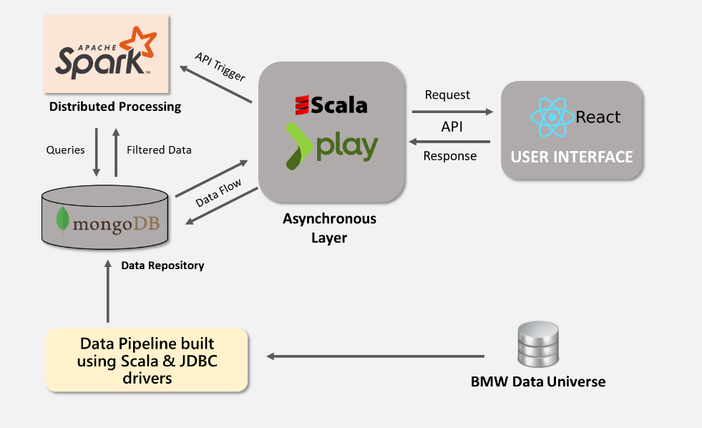

Figure 18: Data Architecture

1. Challenges

#### Data

* Data formats - Data was in a format not directly useable for analytics and had to be heavily transformed
* Missing & Inconsistent data - Older car models do not have data from all the sensors

#### Technical

* Shared Resources - Performance limitations due to virtual machines & spark cluster being shared across multiple teams.
* Low Event Rate Defects - Developing predictive models for defects with event rate as low as 0.1%

1. Improvements

* Data transformed in a format useable for analytics by transforming vector to scalar variables.
* Data descriptive statistics along with percentage of null records displayed when user filters the input data for processing.
* Precomputing results based on user inputs and Batch jobs implemented wherever possible to ensure faster response for user actions on the UI.
* Data-driven configurations to ensure addition of new sensors can be accomodated with minimal development effort

1. SLAs

* Response time for the Web Application needs to be less than 5 sec for certain data visualizations
  + 1. Results & Business Benefits

**SMART INSIGHTS TOOL**

Self-service analytics tool was built in 90 days’ time. The tool runs on the cloud and could scale to even process petabytes of data. Now the user of the tool could play around with it and get answers to their questions faster.

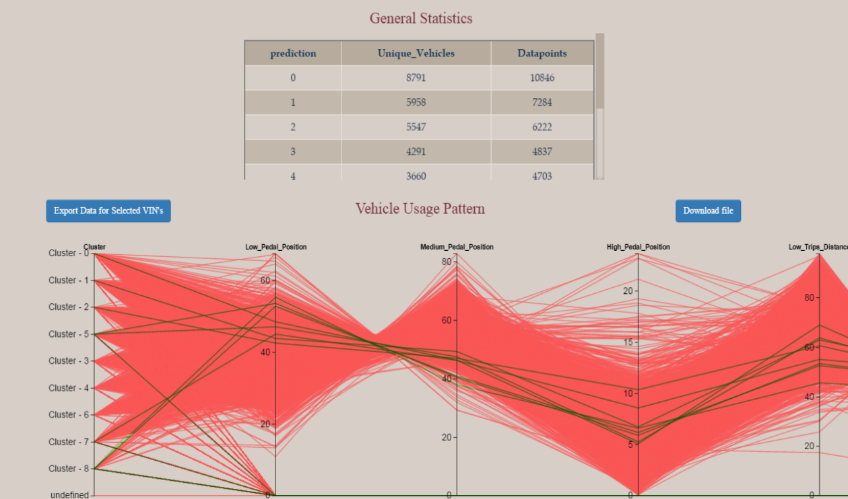

Figure 19: Screenshots of the Smart Insights Tool

**FEATURES OF THE SMART INSIGHTS TOOL**

* Provides a better understanding of Vehicle usage profiles & correlation with Warranty claims.
* Generates insight on Key areas of Product usage & Weakness
* Speeds up Warranty claim analysis, (compared to highly time consuming manual analysis)
* On the fly analysis is now possible
* Uses cutting edge technology for scalability & efficiency
* Machine learning (Scala), Parallel computing (Spark), Amazon Web Services (scalability) and D3 Visualizations are used to bring data to life

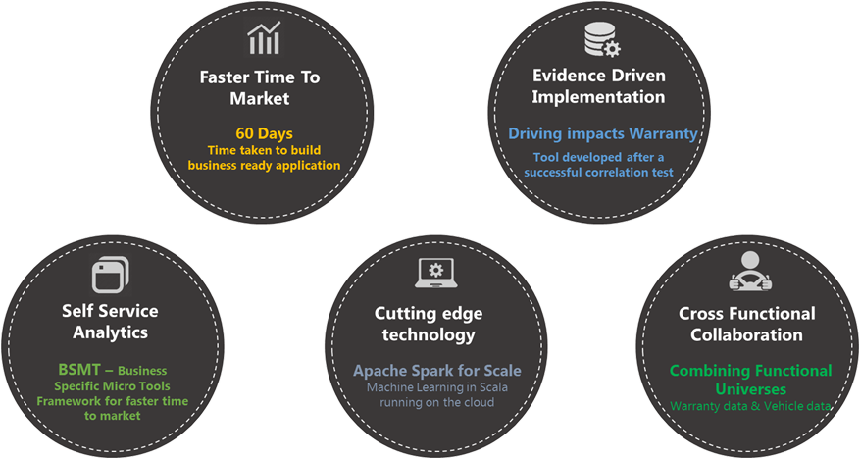

Figure 20:Benefits for Client

* 1. Case Study IV – Digital Metrics Tracking

|  |  |
| --- | --- |
| Client | Leading Global Beverage Company |
| **Problem** | To Provide providing wide spectrum of analysis using social media data like Brand monitoring, Event analysis, Product launch analysis, Weak signal analysis, Purchase Intent, Switchers analysis, Brand association analysis, Influencer analysis, Need space analysis etc. |
| **Solution** | * Digital Metrics Tracker: Integrated platform that tracks all of the digital media metrics in a single place to analyze and market the content in the best possible media. * Product/Innovation Identification: What consumers wants in a product and identify those specific needs that are not met by the current product catalogue and incorporate their needs/requirements in the existing products or as a whole new product. * Opportunity/Need Space Analysis: What are the characteristics a particular demand space, are our products aligned in that direction and what are the consumers’ functional, emotional and technical drivers in selecting a product. * Week/Strong Signal Analysis: What are the reasons behind sales dip or growth and identify those signals that can turn out to be a potentially problem/opportunity for the brand? * Product/Campaign Pre-& Post Launch Analysis: What is the perception of our new product launched in the market or what is the impact of our new campaign and analyse how consumers adopted to their product? |
| **Impact** | * LatentView has been the Digital & Social Media Analytics partner for the Client in implementing Social Media Analytics study, which helped client Marketing team, Global Insights team, Product Innovation Team etc. in positioning their products as well as in focused understanding of the consumer behaviour. * Automated real-time business intelligence application that provided the client an opportunity to view their brands’ social & digital marketing efforts in visually appealing & feature-rich Tableau dashboards. |
| **Tools & Techniques** | * Data extraction and manipulation – Web scrapping through Python, SQL server, Teradata * Data Extraction Paid tools like Radian6 * Presentation - tableau, ppt and web applications * Modelling – R & Python |
| **Operations** | LatentView team continues to maintain the platform, with weekly refreshes to the reports and monthly operational maintenance activities on the data pipeline |

* + 1. Business Context

Analytics & Insights team as well as Marketing team of Client wanted to understand the performance of their marketing platforms and identify the best platform to market a specific campaign. LatentView developed an integrated executive level Digital Media Metrics Tracking tool to track and analyse the campaigns across different marketing platforms and share insights with brand marketing teams

* + 1. LatentView Solution
* LatentView collected and integrated the data from multiple data sources like Owned media (Website), Paid Media (3rd party website banners) and Earned/Social media (Facebook, Twitter, YouTube etc.).
* LatentView developed an automated data extraction procedure by API scripts from various data vendors covering all the above-mentioned sources.
* Designed an ETL layer which will integrate these data at different granularity and functionality.
* Developed a visualization layer to feed the data into the Business Intelligence application.

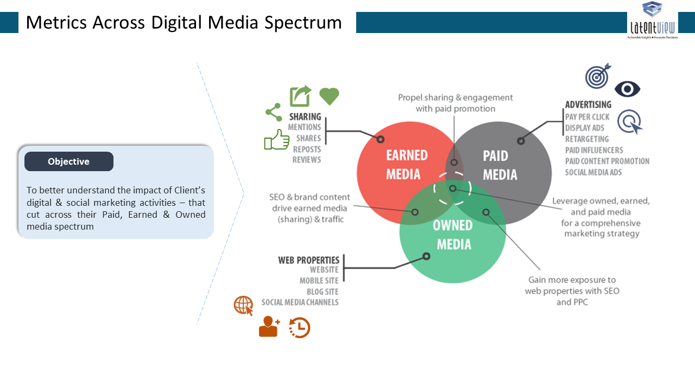

Figure 21: Types of Media

The primary purpose of digital metrics Data Mart is to act as a data source for Client digital metrics dashboard. The overall architectural goal of digital metrics data mart is to provide highly available, scalable and secured data to support reporting and analysis of customer insights team of the client.

The architecture encompasses data retrieval from several media sources to final data mart schema

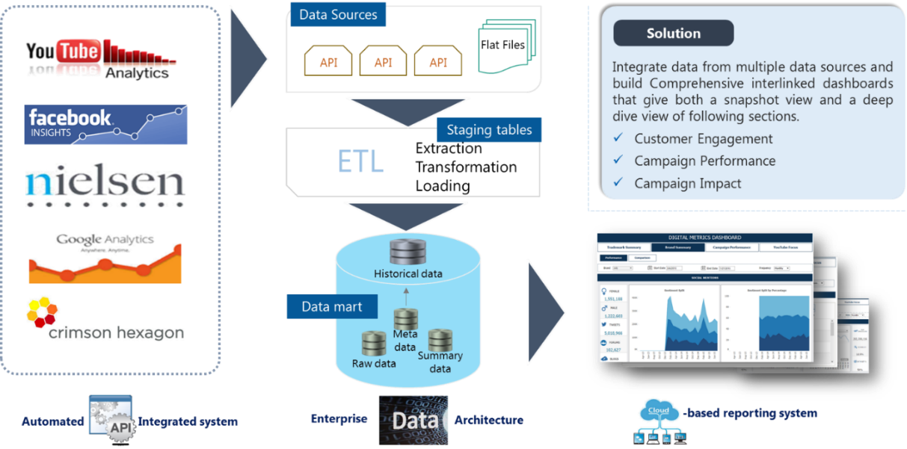

Figure 22: Case Study - Solution Approach

A brief description of the architecture layers is provided below:

* **Data Acquisition**– This layer extracts data from data sources and transfers them to relevant staging tables. This layer is implemented using python scripts
* **Data Staging** – These are temporary or permanent tables which act as a store for the latest data retrieved from acquisition layer
* **Data History** – The data from staging tables is appended to this table from time to time, to maintain an archive of historical data
* **Data Mapping** – The brands and campaigns extracted from the different data sources are mapped with a common referencing for all data sources
* **Data Error** – While data is transferred from staging to summary, checks are done for consistency in mapping to brands and campaigns
* **Data Summary (Socmet)** – The data from different staging tables is combined to suit the requirements of the dashboard and sent to the socmet tables
* **Data Visualization** – In the visualization tables, data from different sources is combined according to the requirement of each dashboard. These tables are pulled by each dashboard directly.

1. Operations & Maintenance

LatentView continues to provide these reports on a weekly basis to the decision makers and also periodically monitors the data pipelines, source APIs and ETL processes.

* + 1. Results & Business Benefits

Automated real-time business intelligence application provided the client an opportunity to view their brands’ social & digital marketing efforts in visually appealing & feature-rich Tableau dashboards.

Enabled CXOs to make quick data-driven insights from the company’s digital & social marketing efforts that cut across their Paid, Earned & Owned media spectrums.

The key benefits of the platform are summarized as

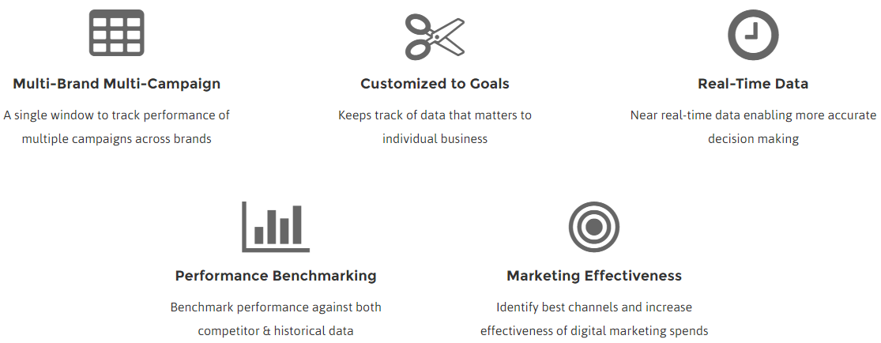

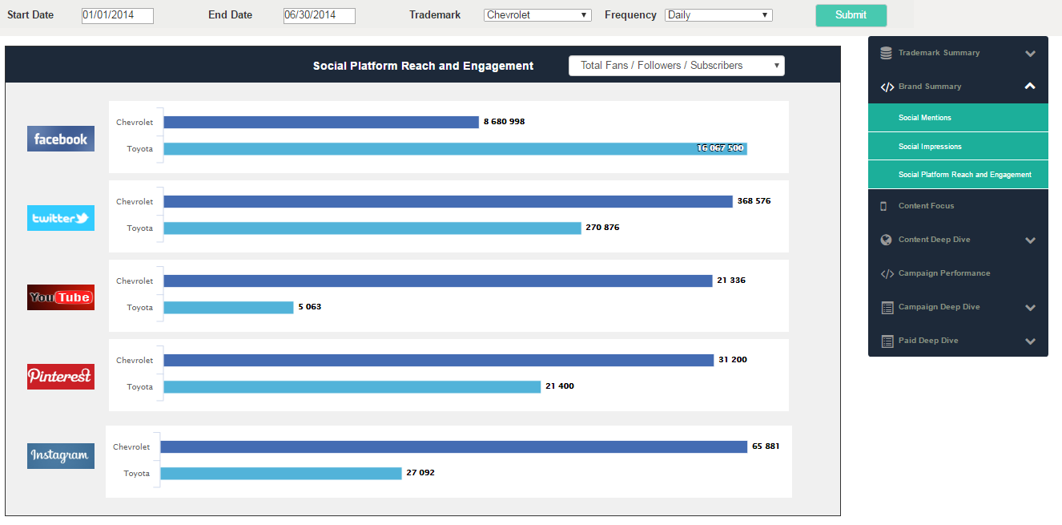

Figure 23: Platform Screenshot

# LatentView Solution Approach for LEGO

LatentView will begin with a review of the business requirement (functional & non-functional) document prepared by LEGO and refine the same based on additional discussions and clarifications with the business team. The next step is a detailed audit of all the existing data elements, required data, technology requirements and technology fit assessment using LatentView’s workload centric technology fit evaluation framework.

Depending on the business use cases identified in the refined requirements document, the target data schema will be designed. Source to target mapping will be done using the designed data schema and identified data elements (existing and new). An ingestion and publication plan that includes the schema, will be developed for each data source based on the audit and will be presented to LEGO’s data engineering team for review and approval. LatentView data engineers will then configure the data pipelines for the data sources and begin ingesting a limited sample dataset.

The sample data set will be verified for data quality to evaluate the completeness, correctness, and conformance/compliance against the method and procedural requirements. Following this a multi-level data validation will be done. The data validation levels include

* Technical integrity of the file, i.e., consistency with the expected IT structural requirements
* Logical and statistical consistency of the data
* Business sense validation

Figure 24: LatentView Solution Approach for LEGO

Full scale ingestion will be done based on the approved plan using the right technology for the right workloads. The data verification and validation process done earlier will be repeated again on the fully ingested datasets. Once passed the business and technical metadata

# Engagement Model For LEGO

* 1. Resourcing
     1. Location

LatentView proposes to deploy one resource at LEGO’s office and the team of data engineer & data scientist to be based in our global delivery centre, Chennai, India for the duration of the PoC.

* + 1. Resource Deployment

LatentView can deploy resources as required by LEGO at their UK & Europe* offices with typical lead times of 4 – 6 weeks for work visa / permit processing. For the short term PoC engagement, resource deployment will be much faster with simpler visa requirements

*, First long-term deployment at LEGO office in Denmark might take longer if regulations require setup of a business entity in Denmark.

* + 1. Resource Movement & Handovers
* LatentView resources are tied to specific client projects thus minimizing service disruptions
* During planned resource movements we ensure an equivalent skilled resource is provided and a detailed knowledge transition plan is implemented (See Section 9.6.3 for further details on LatentView’s Knowledge Transfer & Documentation policies)
* LatentView has robust policies in place to ensure that the working knowledge in projects is captured effectively, so that there is no disruption in servicing client requirements. See the Knowledge Management Strategy in Section 9.6.2
  1. Operations
     1. Onsite Activities

LatentView’s onsite resource deployed at LEGO’s office will serve as the SPOC coordinating the daily operations of the engagement including connecting with all the stakeholders to understand business requirements, seek clarifications from LEGO business / technical teams, coordinate with the IT infrastructure team, enable the team discussions between LEGO team members and all LatentView team members as required, present the completed work to LEGO teams. Typically, about 30% of the onsite person’s time is spent on these activities and the rest is spent in collaborative working on the data engineering activities along with the client teams.

* + 1. Offshore Activities

The offshore team will understand business requirements from onsite counterpart or directly from LEGO team, work on the requirements, collaborate with LEGO teams as required, liaison with LatentView’s senior data engineering experts (if required), prepare detailed documentation and participate in team discussions.

For more detailed information on the onsite – offshore model and the operating activities see section

* + 1. Time Zone Management

Working with clients across Europe, UK, US & APAC, LatentView has developed mechanisms to enable effective and prompt co-ordination and collaboration across teams. LatentView’s flexible work hours policy also ensures that we are able to coordinate with our clients at optimal times across geographies.

With a very significant time overlap in working hours at LEGO office locations and our delivery centre in Chennai, collaborative working will be effective. Our onsite person will serve as a SPOC for the LEGO team and coordinate with the offshore resources.

* 1. Code Versioning

LatentView typically uses GitHub as the web-based repository cum hosting platform. GitHub is preferred for code versioning due to its distributed revision control and source code management (SCM) functionalities. LatentView team members will be comfortable working with any such commercial platforms like Jenkins, GitLab, BitBucket, Maven or another.

LatentView does use the Continuous integration and continuous deployment (CI/CD) for most client application development projects to deliver incremental improvements to the solution. We will use the CI/CD process with Docker CaaS platform for specific use cases of LEGO.

* 1. Transition

When LEGO decides to transition the data systems / maintenance activities either in-house or to another vendor, LatentView will take the responsibility for managing the transition. LatentView will develop a transition plan and LEGO will coordinate and signoff on the transition plan. LatentView will be responsible to deliver documentation on the schemas, code base and knowledge transfer of the process. Any data residing in LatentView’s IT infrastructure will be delivered to the informed location before sign off. LatentView will arrange training of successor vendor’s or LEGO resources in shortest time possible. If any proprietary or third-party tool is used in the project, LatentView will continue providing support if required.

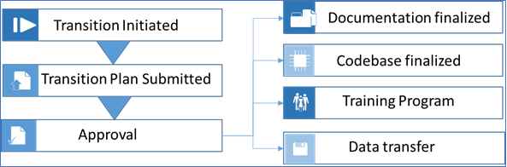

Figure 25: Transition Management

* 1. Agile Methodology & Experience
     1. Methodology

LatentView shall follow a collaborative model of implementation in analytical solution development projects, allowing us to keep delivering incremental working versions of the final solution. However, we will clearly define the phases at a high level from initial requirements phase to build phase to roll out phase.

The Collaborative Model aims to combine both the models – Waterfall and Agile. Leveraging both the Waterfall and Agile approach ensure the success of the project. It removes the disadvantages of both the models; while bringing together the advantages of both.

The Collaborative Model can be implemented in a project by executing:

[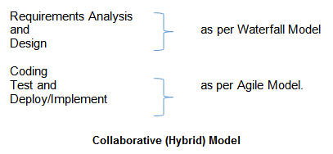](http://cdn.softwaretestinghelp.com/wp-content/qa/uploads/2015/02/Collaborative-Hybrid-Model.jpg)

So, the Collaborative model can be represented diagrammatically as below:

[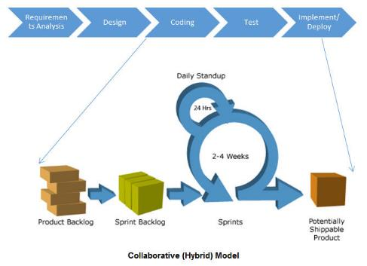](http://cdn2.softwaretestinghelp.com/wp-content/qa/uploads/2015/02/Collaborative-Hybrid-Model-2.jpg)

Reference: <http://www.softwaretestinghelp.com/agile-waterfall-hybrid-model/>

**Advantages of the Hybrid model**

* Combines the benefits of both Agile and Waterfall processes.
* High-level design is prepared applying waterfall principles.
* Coding and testing is done using agile methodology

During the initial phase, LatentView shall need a great deal of input from LEGO.  The deliverables for this phase of the project are functional and technical specifications and user stories that details the breakdown of sprints in distinct timelines and features.  These deliverables help ensure project success and help facilitate clear communication by all stakeholders before implementation begins. Upon approval of this roadmap, LatentView would proceed to implement build phase using agile project techniques.

The following processes/deliverables will be part of a typical analytical solution development cycle

* System Requirements Document: All system requirements shall be documented after the requirements phase.
* System Design Document: System level design specification shall be produced which will serve as the blueprint for the entire development. This will contain two distinct parts.
* Functional Specification
* Technical Specification
* Verification/Test Protocols: Test cases shall be developed in parallel from the requirements by an independent team
* Requirements Traceability Matrix: Traceability matrix shall be maintained. This shall ensure the team to perform impact analysis on any change in the requirements in the future.
* RACI Matrix: RACI matrix shall be produced at the initial phase. This helps in identifying roles and responsibilities early in a project.
* R- Responsible, A-Accountable, C- Consult, I-Inform
* User Guides: Shall be produced during the closing stages of the project
  + 1. Tools to Enable Agile Development

LatentView teams have extensive experience using Agile project management tools like JIRA and ZOHO sprints that supports agile methodology. We use agile boards to report, plan, track, and manage the entire agile software development engagement provided by the chosen tool.

* + 1. Agile Development of Reporting Platform

In analytics projects, many a times the scope is loosely defined and it gets evolved over the time. Compared to the traditional waterfall model, LatentView prefers the agile methodology. In one of the projects for a large payment gateway company, the client we were working directly belong to their internal analytics team. The client has to deliver a set of reporting dashboards to a set of internal business stakeholders. The requirements weren’t exactly frozen at the start and the stakeholders wanted to track some of the key metrics quickly. We suggested an agile methodology for this project and delivered a base version of the report to the stakeholders. The initial report provided more clarity to the stakeholders on prioritizing the needs. Taking the stakeholders’ feedback into consideration, we improved the design and content of the reports. After few such iterations, we were able to provide the required business insights to the respective stakeholders.

* 1. Global Delivery Experience

LatentView recommends a COE model for the full-fledged engagement with LEGO after the POC.

Based on our experience working with a number of clients across the globe, we have arrived at a view of analytics COE as an enabler of the various analytics solutions for the client’s business areas. The key expectations of COE are

* Enable analytics solutions for various regions across different functional areas
* Transfer learnings from wins in a region to other regions or functional areas
* Look out for the latest development in technology across data management, visualization, and data science solutions
* Conduct POCs to study and implement latest technologies to improve business performance

We help client organizations in their analytics journey in a structured way.

1. **Analytics Maturity Assessment** – Assess the analtyics maturity of client organization using LatentView proprietary framework. Output is the list of current and proposed state of analytics for the clients
2. **Analytics Opportunity Mapping Discovery** – Building on the maturity assessment output, we do a analytics discovery exercise to identify analytics opportunities for each business unit of the client. Output of this exercise is a list of projects ranked according to their imapct and feasibility, along with estimated timelines for the projects
3. **Enterprise Reporting Solutions** – Identify the analytics opportunities that could be delivered through reporting and visualization solutions. Develop and implement said solutions using LatentView best practices for enterprise reporting projects
4. **Data Science Solutions** – Identify the analytics opportunities that could be fulfilled through analtyical models. Develop and deploy said solutions using LatentView best practices for data science projects
5. **Scaling up the COE** – Scale up the operations of the COE to other business areas and other countries
   * 1. Building CoE Partnerships – Advantages with Pure Play Analytics Partners

* Enterprises have multiple choices as regards building Analytics COEs, including internal teams, software outsourcing firms, consulting firms and pure-play analytics firms. The key advantages of building COEs with pure-play analytics firms, we believe, is that the ROI is higher as compared to other options. The 2 factors that contribute to the higher ROI are the benefits from better output (accuracy of predictions, model performance etc.) and the lower total cost of outsourcing (lesser learning curve, cost advantage of delivery model etc). These 2 factors are influenced by:
* ***Experience in engaging directly with business and analytics teams*** – unlike the other types that work with IT or Strategy teams pure-play analytics firms work directly with business and analytics teams. This ensures better understanding of the client’s business problems and steeper learning curve during transition.
* ***Focus on problem solving using data*** – our focus is on finding solutions from the data. So our approach, thinking and training is tuned towards mining data. This ensures that we are faster in solution development and require less hand-holding by clients.
* ***Looking for ‘actionable insights’*** – unlike the other types of analytics service providers our team members are focused on deriving insights from data. Culturally we are tuned to ensuring the insights make business sense. This ensures the business has insights and recommendations that they can act upon and the insights are not academic.
* ***Cross-pollination of Ideas*** – we work and consult with clients across different domains (CPG, Retail, BFSI, Technology etc.) in providing analytical solutions for various business problems. Given our core offering is in analytics, the learnings from solving a problem from one vertical/domain can be applied in providing solutions to a similar or completely different problem in a different vertical.
  + 1. Case in Point
* LatentView has been engaging with a US based global payment gateway company since 2010. The engagement kicked off with a 6 member team with KPI reporting. This scaled up as an analytics Center of Excellence (CoE) now catering to about 35 teams. Currently a 100+ member analytics team is engaging with various regional and global marketing teams (North America, Latin America & Asia Pacific).
* LatentView was quick in understating client’s business processes and grew from being involved in execution based projects to key strategic initiatives. LatentView has helped the client on broad issues such as reducing revenue leakage to specific issues such as increasing sign ups. Also, involved from conception, market sizing, launch and post launch impact analysis of new products, targeting both consumers and merchants which has improved targeting & ROI.

The picture below gives an illustration of the engagement and our growth with this client over time.

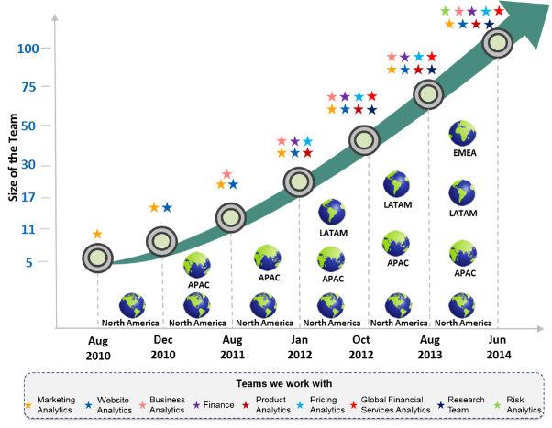

Figure 26 : Client Engagement Growth in CoE Model

* 1. Experience in Handling Development on systems in compliance with GDPR & Data Security Policy

For one of our clients, a global financial payment gateway provider with operations in US, UK and APAC, we developed an analytics application on Hadoop platform. The client has very strict policies towards data security. Following are the set of best practices which helped us to achieve this:

* Access to client resources: Only client authorized team members can access the client data. No sharing of data without getting client approval. Off-shore teams log into the platform via secured VPN and then sign into the specific server and project. Permissions align with the functions performed by the team members.
* Security Certifications: LatentView has ISO 27001 and PCI-DSS(Payment Card Industry Standard) Certifications.

* Physical Security Standards: Physical security of the site is ensured by 7x24x365 guards with Biometric authentication and video monitored. All access is logged and tracked.
* Client Specific Security Measures: Any addition/deletion of a resource is intimated to the client immediately and all access to data is restricted immediately upon removal

LatentView as the data controller in the above-mentioned engagement followed the GDPR guidelines for Controller and additional guidelines as provided in client’s data security policy. As typically done for client engagements involving data engineering, LatentView assumes the dual role of a controller and processor and followed both guidelines in addition to the client guidelines

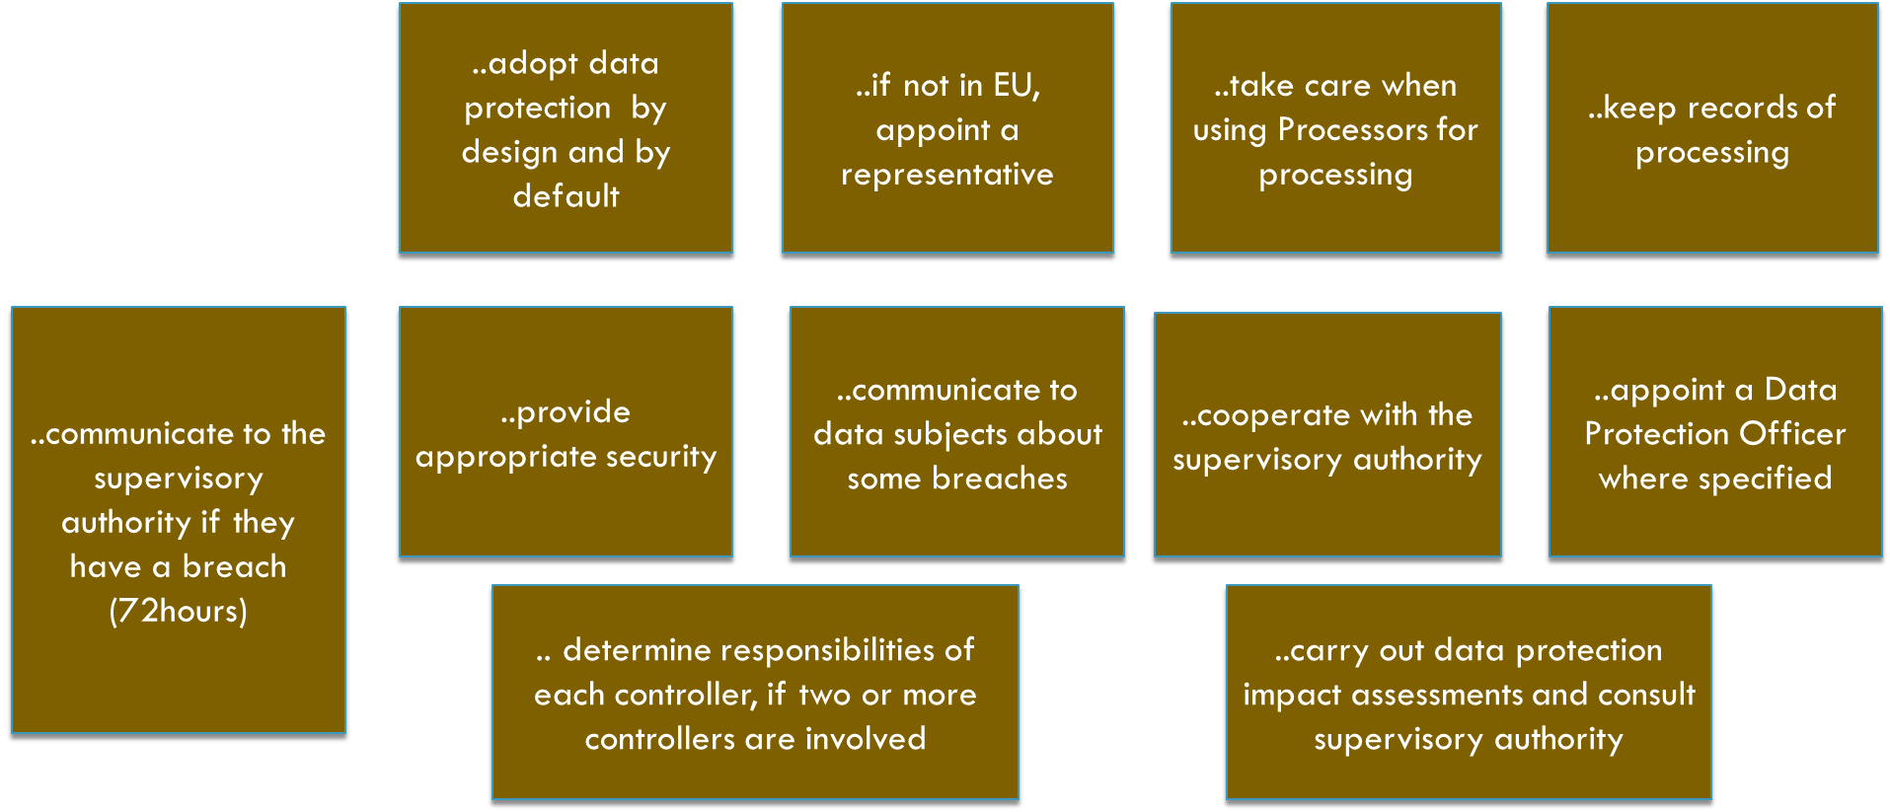

Figure 27: Controller Responsibilities as per GDPR

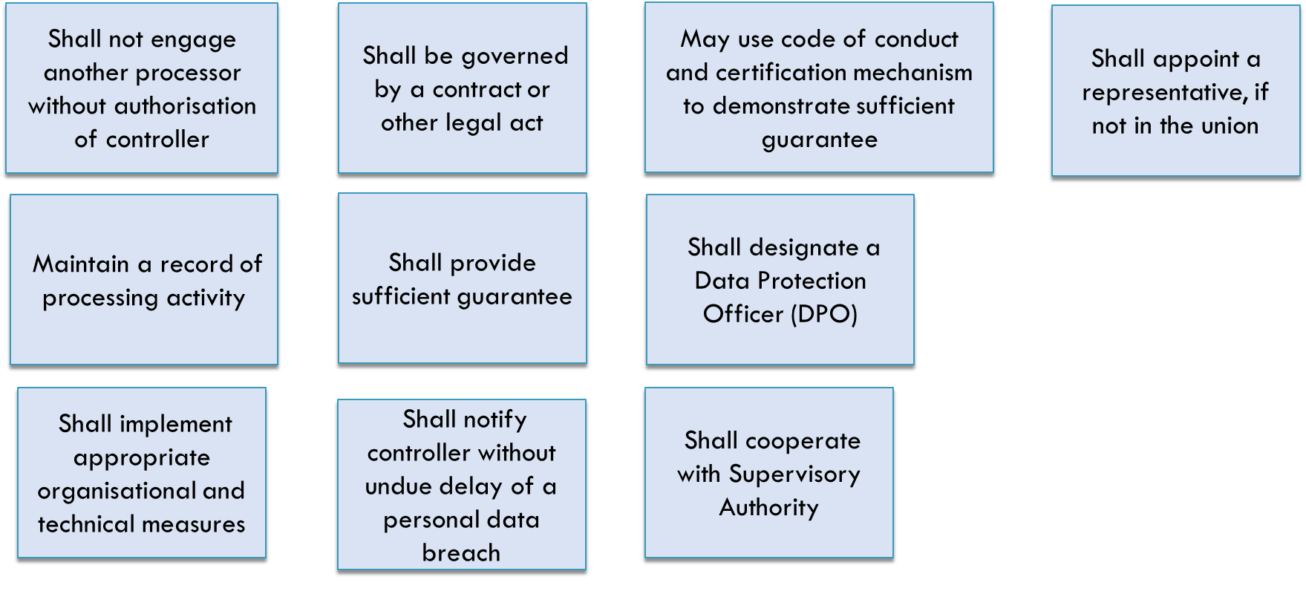

Figure 28: Processor Responsibilities as per GDPR

* For a more details on LatentView’s data security policies and systems see **Section 9.7**

# Commercials

* 1. Resource Skill Set

|  |  |
| --- | --- |
| **Resource Type** | **Skill Set** |
| **Senior Data Engineer A**  *(5 + Years)* | **Experience in Governance & Engagement:**   * Client Communications, Business requirements & Work scoping * Project Management & Delivery SLAs * Operational maintenance of enterprise implementations   **Experience in Data Engineering:**   * Design, Architecture & implementation Data engineering solutions * Various Cloud/Enterprise infrastructure, Legacy & modern Database & ETLs * Processing all forms of data (Unstructured, Structured, External & Internal) |
| **Data**  **Engineer B**  *(3 + Years)* | **Experience in Governance & Engagement:**   * Offshore Project Delivery & SLAs * Operational maintenance of work flows & Delivery SLAs   **Experience in Data Engineering:**   * Maintenance of Data engineering solutions * Development of Data engineering workflows (Data Ingestion, Publication & Processing) * Project Specific Cloud/Enterprise infrastructure, Legacy & modern Database & ETLs * Processing all forms of data (Unstructured, Structured, External & Internal) |
| **Senior**  **Data Scientist A**  *(5+ Years)* | **Experience in Governance & Engagement**   * Client Communications, Business requirements & Work scoping * Project Management & Delivery SLAs * Development, implementation maintenance of analytics solutions   **Experience in Advanced Analytics**   * Combining Business, Data & Math for business problems * Reporting & Visualization (Legacy & Open Source), Predictive modelling, Text Mining & Lexical processing of unstructured data. * Tool & Programming experience including Python, R & visualizations. |
| **Data**  **Scientist B**  *(3+ Years)* | **Experience in Governance & Engagement:**   * Project Management & Delivery SLAs * Development, implementation maintenance of analytics use cases & business analysis   **Experience in Advanced Analytics:**   * Combining Business, Data & Math for business problems * Project specific experience - Reporting & Visualization (Legacy & Open Source) or Predictive modelling or Text Mining & Lexical processing of unstructured data. * Tool & Programming experience in Python / R / Tableau / Open sourcing visualizations. |

* 1. Pricing for the PoC

|  |  |  |  |  |  |
| --- | --- | --- | --- | --- | --- |
| **Resource Type** | **Years of**  **Experience** | **Day Rate  (Eur)** | **Location** | **Number of  Man Days** | **Cost** |
| **Senior**  **Data Engineer A** | 5 Years | **€**580.00 | London | 20 | **€** 11,600.00 |
| **Data Engineer B** | 3 Years | **€**240.00 | Chennai | 20 | **€** 4,800.00 |
| **Senior**  **Data Scientist A** | 5 Years | N/A | Chennai | 20 | - |
| **Data Scientist B** | 3 Years | N/A | Chennai | 20 | - |
| **Total** | | | | | **€** 16,400.00 |

Total charges for the Proof of Concept in this offer shall not exceed **Sixteen** **Thousand Four Hundred Euros (€16,400.00 exclusive of VAT & taxes) \*\*** without Lego`s prior written approval.

*(In GBP, the PoC value is* ***£14760.00*** *assuming conversion rate of 1 EUR = 0.9 EUR*)

The prices are exclusive of VAT & Taxes, if any. LatentView will take care of all employee related & travel related costs. The price does not include cost of licenses to source the social media data & does not include any infrastructure cost required outside Lego`s setup.

Any work spillage or extension of work due to delays from Lego can be accommodated up to 2 weeks and any further extension will be charged in the existing pricing structure. Any modification, redefining or extension of the original work scope during and after consulting requires revised offer and approval.

* + 1. Assumptions

Following are the assumptions for the start and duration of the engagement

1. The engagement requires a single **Point of contact/Program owner** from Lego for faster and efficient execution.
2. LatentView (Data security policy) prefers the solution development, deployment and maintenance to be performed in **Lego Network & Infrastructure.**
3. The proposed timelines assume the required **data & infrastructure** are made available within first week from the start date
4. If in the given period the amount of work requests exceeds the capacity available in the team, Program owner will prioritize the work schedule for the team in Conjunction with the LatentView Engagement Manager.
5. All Services shall be treated as **Confidential Information** unless otherwise designated by BMW.
6. The deliverables from LatentView requires **feedback and turnaround** from Lego within 3 business days for timely execution & completion of the projects.

**LatentView - Indicative Rate card:**



# Data Science Case Studies

* 1. Case Study I: Early Warning System (EWS) for Networking Company

|  |  |
| --- | --- |
| Client | The client is an American multinational corporation that designs, manufactures and sells networking equipment |
| Problem | To develop statistical models based on structured and unstructured data in order to accurately predict the probability of incoming service request turning into CAP |
| Solution | Developed an Early Warning System based on statistical models, in order to identify SRs that had a high propensity of turning into CAP |
| Impact | Increased the capture rate of SRs by 9%  The overall benefit of servicing 5000 SRs recommended by the model was around $8.5 Million |
| Tools, Technologies & Techniques | Combination of Logistic Regression, Stochastic Gradient Descent, Random Forest and Gradient Boosting Model used in building the EWS  SAS/ My SQL/ Excel/ Tableau/ Python are the tools used for building model and for reporting insights |

* + 1. **Business Context**

Client has customers all over the globe and some of them are characterised as critical customers. These critical customers are serviced under a program called as Critical Assurance Program (CAP). The cost serving a customer under this program is anywhere from $400,000 to $2 million.

If a customer turns critical then it had a substantial impact on the bottom line of the company. The Client wanted an Early warning system to identify the clients that had a high propensity to reaching the critical level. These clients would then be serviced at an early stage, thus keeping them away from the CAP stage.

* + 1. **LatentView Solution**

LatentView worked with engineers, CAP managers and other business users to understand the managerial hypotheses and decision strategies driving their current approach. Armed with solid business understanding, LatentView prepared the ground for advanced analytics by extracting structured data for five years and used and historical trends to indicate whether specific technology, software and hardware have turned CAP in the past.

1. **Exploration**

With the data foundation in place, LatentView began by exploring various data and used four statistical models–Logistic Regression; Stochastic Gradient Descent; Random Forest; Gradient Boosting Model for further evaluation.

1. **Decision Optimization**

The results from Logistic model were superior then other three models. The model gave a lift of 8.5 times in the first decile. Basic methods of data extraction were tedious and time consuming due to large volume (~100GB) of unstructured data. So, multi-threaded Python code was built to extract data after investing time and effort into exploring several other approaches. The client was provided with a simulator that identified the customers that had a high propensity of turning critical with an accuracy of 74%.

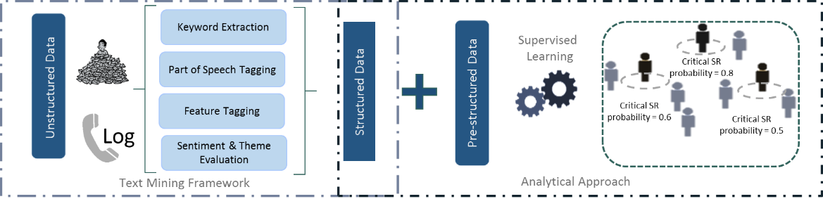

*Figure 292: LatentView Early Warning System*

* + 1. **Results & Benefits**

Couple of months into the analytics driven transformation, the client witnessed a significant reduction in clients turning critical. The capture rate was increased by 9% in the solution provided by LatentView. Adding to this LatentView provided the client an excel simulator which can be used to simulate the cost impact from various business scenarios.

* 1. Case Study II: Media Mix Modeling for Spend Optimization

|  |  |
| --- | --- |
| Client | One of the leading American Home Services Company |
| Problem | To build a tool to automate media mix modelling for various combinations (Channel x Product X Geography) thereby optimizing spend allocation |
| Solution | * Data is pulled from DataMart and R is used for data modelling * Modelling is performed at Channel X Product X Geography. The results are stored in a table * Data is pulled from DataMart and R is used for data modelling * Modelling is performed at Channel X Product X Geography. The results are stored in a table * Results from S-Curve is used to create optimization scenario using non-linear optimization algorithm * The results are stored in a table |
| Impact | * Higher accuracy leading to Improved visibility and better planning by Territory managers * Paid Search (38.59%) and Natural Search (40.88%) are the largest revenue contributors * Paid Search has a significant impact on other vehicles (Display 17.5% and Natural Search 11.9%) but Natural Search has low relative impact on other vehicles * Email is significantly correlated with Natural Search (0.27) as compared to other vehicles |
| Tools, Technologies & Techniques | * Data analysis, extraction and manipulation were done using MS-SQL Server & R programming * Web application development was done using Java |

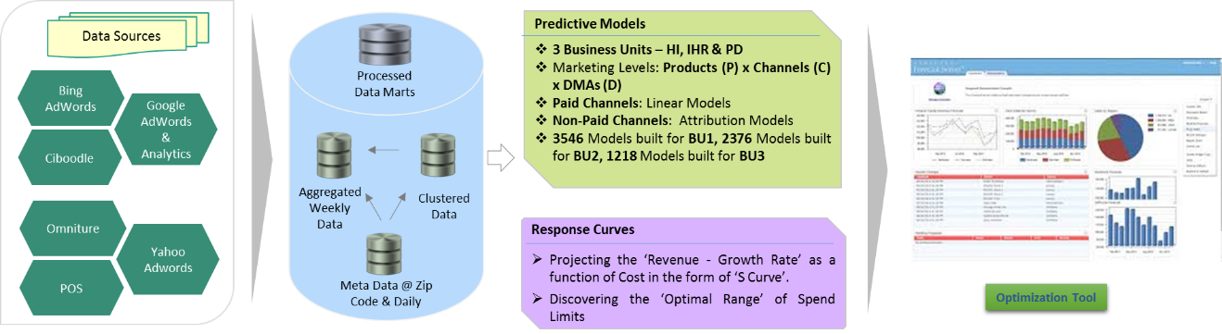

Figure 30: Media Mix Modeling – Process Flow

* 1. Case Study III: Forecasting of Games Sales

|  |  |
| --- | --- |
| Client | One of the Largest Global Technology Companies |
| Problem | To forecast sales from new games well ahead of their launch |
| Solution | * Two models are used depending on the time of forecast: * A BASS Diffusion Model - When the date of forecast is more than 180 days from the date of game release * Linear Model - when the date of forecast is less than 180 days from the date of game release * The linear model uses both structured - sales data, and unstructured - social media data, Wikipedia data |
| Impact | * Our model results were significantly better than that of the in-house approach * The models help the business team plan better for the games launch |
| Tools & Techniques | * R, linear regression, bass diffusion |

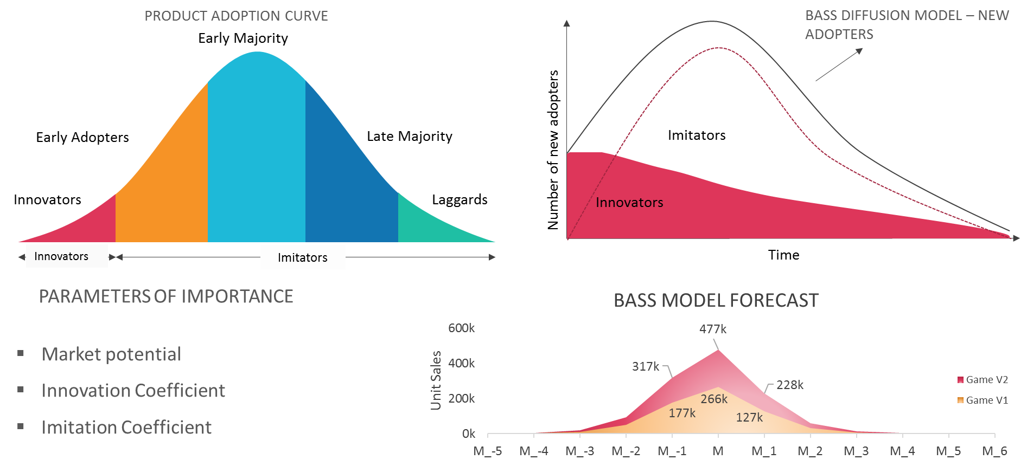

Figure 31: Case Study – Forecasting Games Sales

# LatentView Overview

* 1. About LatentView
* LatentView Analytics is one of world`s largest and fastest growing data analytics firms. LatentView helps companies improve their analytics maturity through innovative, business driven, and result oriented solutions backed by cutting edge tools and techniques. We specialize in integration and analysis of all forms of digital & traditional data and deriving actionable insights for smarter business decisions. Our solutions help in performance improvement, efficiently trade off risks against available opportunities, maximize customer value and increase employee effectiveness.
* LatentView’s blend of business knowledge, expertise in quantitative methods, and data management helps us provide end to end business solution, as depicted in below figure

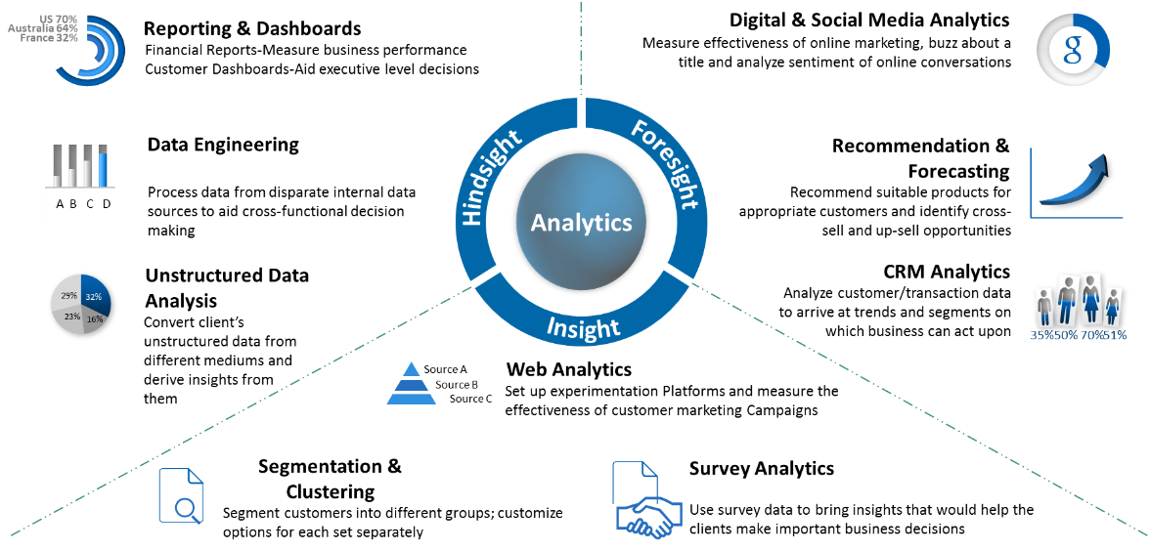

Figure 3: About Latentview

* LatentView is headquartered in Princeton, NJ with its global delivery centre located in Chennai, India and has multiple offices across the world including the USA, UK, Netherlands and Singapore. LatentView has invested in getting the right combination of business & subject matter experts at/near client locations to service the client’s needs. By combining its client-servicing intent, people skills and enabling investments LatentView has successfully delivered projects across many fortune 500 clients.

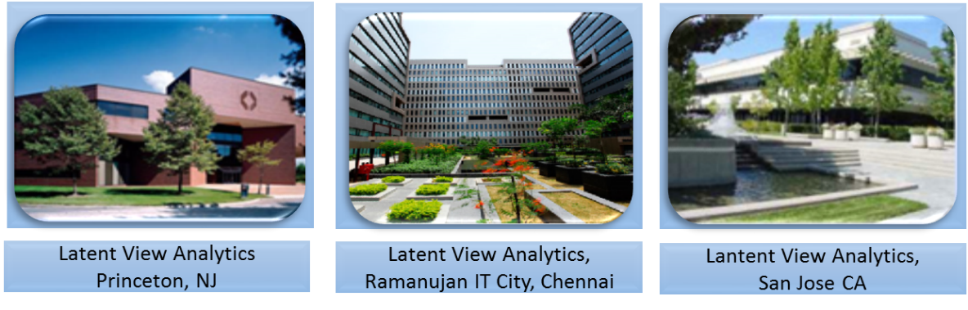

Figure 4: LatentView Office Locations

* 1. How are we different

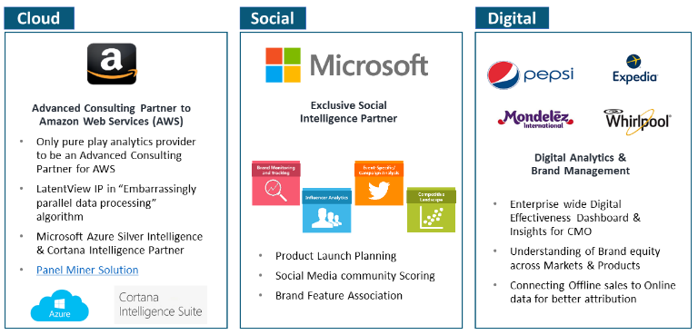

Figure 335: LatentView Differentiators

* **Specialists in Business Focused Analytics:** **1 in 3** of our employees have a **business background** as we believe Analytics is a combination of Business + Data + Math. At LatentView we work towards providing business led solutions that has the most impact to the client’s top/bottom line
* **Experts in Unconventional Data Sources & Cloud-based Data Ecosystem:** With the changing data landscape, LatentView has the right mix of people, technology and work experience to handle both structured and un-structured data to generate greater business value to our clients. LatentView has over the years developed deep expertise in working with various cloud platforms like AWS, Azure and Google cloud. We have built strong networking partnerships with Amazon and Microsoft Cloud that enables us excel in this area
* **Cutting Edge, Customizable Proprietary Solutions & Reusable Framework:** Being a pure play analytics player, AI/ML and Deep Learning form the core of most of our solution offerings. We have the right level of skill sets and experience when it comes to building cutting edge analytics solutions using these advanced techniques
* **Expertise in Digital Marketing:** More than 70% of our body of work revolves around digital marketing for some of the world’s most leading organizations. For the past 11 years, we have built this expertise by working with several Fortune 500 firms like Microsoft, eBay, PayPal, Facebook, Google etc.
* **Exclusive Social Media Analytics Partners:** We have partnered with various clients ranging from media houses to leading software providers and helped them leverage social data to enhance business insights. We have helped firms like Pepsi, Microsoft, Whirlpool etc. use social data in product launch planning, brand feature association studies, and even advance their innovation processes
* **Focus on Innovation & Thought Leadership:** With its internal *IdeaLabs teams* and strong academic partnerships LatentView is always committed to be a step ahead when it comes to incorporating the latest available platforms or techniques that can generate superior value to its clients
  1. Our Achievements
* LatentView is a recipient of the prestigious **‘Analytics Solutions Provider of the Year’** at the **2017 Frost & Sullivan India Digital Transformation Awards**
* LatentView has been a proud winner of the **Deloitte Technology Fast 50** in India for nine consecutive years, a testimony to the strong growth and engagement record with our client base
* **Gartner** - Cool Vendors in Analytics
* Awarded as one of the Top 20 emerging companies in the field of analytics in IE20, London

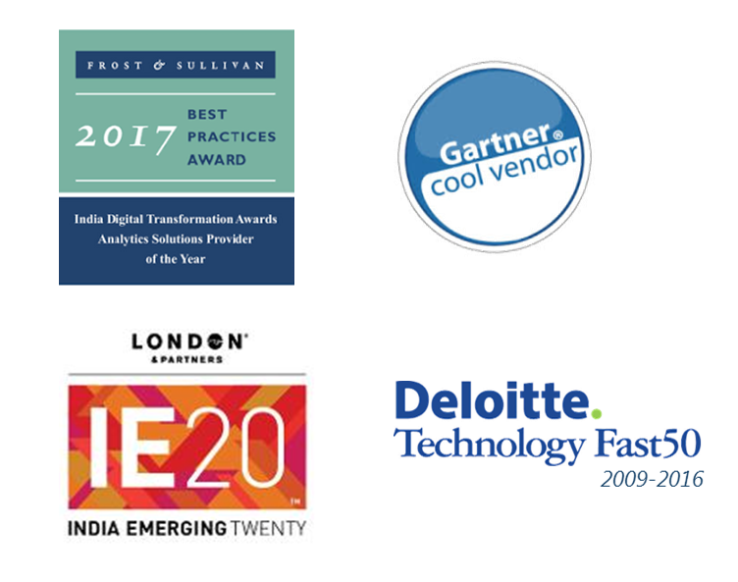

Figure 346: LatentView Awards and Recognitions

* 1. Our Partnerships
     1. Analytics Technology Partnerships

LatentView closely follows the latest developments on the technology side in the analytics industry. Power BI, Visual Studio, SQL Server, Azure SQL DB, and Azure ML Studio are some of the prominent platforms used for various analytics projects within LatentView. As a result, LatentView has been recognized as a partner of **Cortana Intelligence Suite** and listed on the partner website

(<http://cortanaintelligencepartners.azurewebsites.net/>).

LatentView is also currently pursuing the **Gold Data Analytics** competency as a member of the Microsoft Partner Network.



Figure35: LatentView Partnerships

* + 1. Academic Collaboration

LatentView works closely with some of the prestigious academic institutions in the country. We regularly conduct Analytics Conferences across the US where we invite eminent professors to address a select set of invited clients on the latest innovations in the analytics industry. We would like to highlight LatentView's Fifth Analytics Roundtable and the work we have done with two of the top institutions in India – Indian Institute of Technology Madras (IITM) and Indian Institute of Management Calcutta (IIMC)

**Indian Institute of Technology Madras (IITM)**

LatentView entered into a MoU with IIT Madras in March 2015 to collaborate on building advance analytics solutions. As part of this MoU LatentView has been involved in the following activities

* Pramad Jandhyala (Founder) is a member of the **Executive MBA Advisory Committee**
* **Best Paper Award** for a joint paper titled “*Social Media Sentiment Analysis: Are the existing methods reliable?”* at the International Symposium in Honor of Dr. Ravi Ravindran at Indian Institute of Science in March 2015
* **Forecasting Model publication** – *Multi-Objective Deterministic Pseudo- Evolutionary Algorithm for Time Series Data is* under review for the book Big Data Analytics Using Multiple Criteria Decision Making (MCDM) Models

**Indian Institute of Management Calcutta (IIMC)**

Ganesh Sankaralingam, Director (West Coast) was a member of Industry Conclave on Business Analytics which designed the curriculum for the Post Graduate Diploma in Business Analytics program led by Indian Institute of Management Calcutta (IIMC) in association with the Indian Statistical Institute (ISI) and Indian Institute of Technology Kharagpur (IIT-KGP). The first batch commenced in June 2015 and is expected to graduate in March 2017. LatentView is also offering a core course as part of the program titled – Business Data Mining

* 1. People Development at LatentView
* Learning and development is an integral part of our employee value proposition. At LatentView, learning is not restricted as a time-bound initiative but an intrinsic part of our organization's culture. Our learning organization culture strengthens employee skills, equipping them with business, technical and behavioral competencies needed to perform their role with excellence. Our employees consistently develop competencies through on-the-job work experience, formalized classroom-based training, self-initiated learning and interaction with specialists.
* We are committed to “Actionable Insights - Accurate Decisions”. We understand the need to enhance the capabilities of our employees continually and build on their experience. To enable this continuous learning, we provide an environment that encourages each employee to learn, teach, and share knowledge with his or her colleagues through initiatives like **LEAP** (Learning Excellence Acceleration Program which drives self-initiated learning via online courses from a plethora of learning platforms) , **Learning Tuesdays** (Professional Class-room based customized skill based trainings by external industry experts) , **Learning Boards** (Online portal with all learning resources with guided learning paths for upgrading employees proficiencies in various skills) and **hands-on skill-based workshops**.
* LatentView learning & development is committed to providing training to deliver superior solutions, whether in advanced analytics solutions, emerging or established technologies, or professional skills.
* At LatentView, we have identified that our people are our key strength and we have developed a number of initiatives focused on people development. We have a dedicated Learning & Development team, headed by our Chief People Office, which is focused on facilitating these initiatives. A few of the initiatives are explained below.
* **LEAP**: A program to incentivize people to take up online courses of top ranked universities such as MIT, Stanford. Over the last 1 year, more than 20% of our workforce has been trained under the LEAP program
* **Classroom based Workshops:** These are to improve the skillset of our people on a few niche areas of Analytics such as Social Media, Survey Design & Analytics, Bayesian techniques, cloud technologies such as AWS, etc.
* **Hackathons**: We conduct Data Analytics Hackathons every quarter to expose our people to new areas of analytics. These hackathons provide the opportunity for our teams to work on problems that are outside their daily work
* **People Skills Training**: We believe that to deliver impactful solutions to our clients, our people should have strong communication, inter-personal skills. This training is aimed at equipping our team members in said skills and over the last one year, more than 25% of our people have undergone this training
* 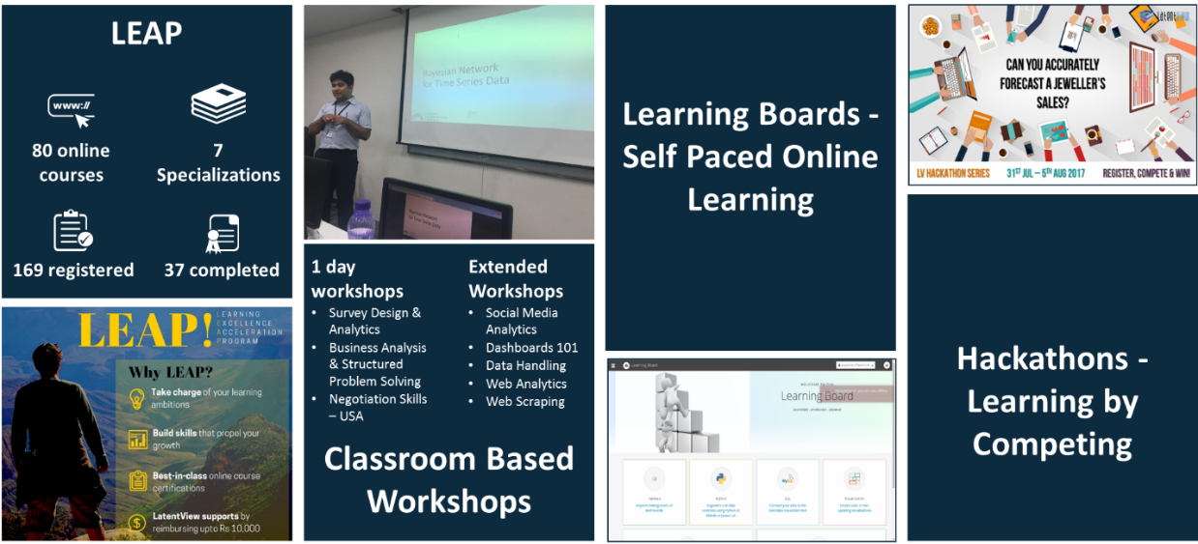

Figure 367: LatentView People Development Activities

* 1. LatentView Operating Model & Processes

LatentView has robust policies in place to ensure that the working knowledge in projects is captured effectively, so that there is no disruption in servicing client requirements. Our project governance, risk management and knowledge management processes are aligned to this goal.

* + 1. Engagement & Governance

LatentView has managed and executed multiyear engagements for stakeholders including **Global payment gateway (120+ team), global e-commerce company (50+ Team)** and **large software giant (70+ Member team)** through a CoE Model architecture. Over the years, we have developed several processes and frameworks which have successfully added value in terms of delivery efficiency, quality management and thought leadership across various stakeholders.

A successful Delivery Governance Framework currently in use in a large 120+ member engagement for one of our clients is shown below. The client is a Fortune 500 payment gateway company (only three streams are shown in the diagram below – while in reality our client has 16 streams). A similar framework can be proposed for LatentView’s engagement with LEGO

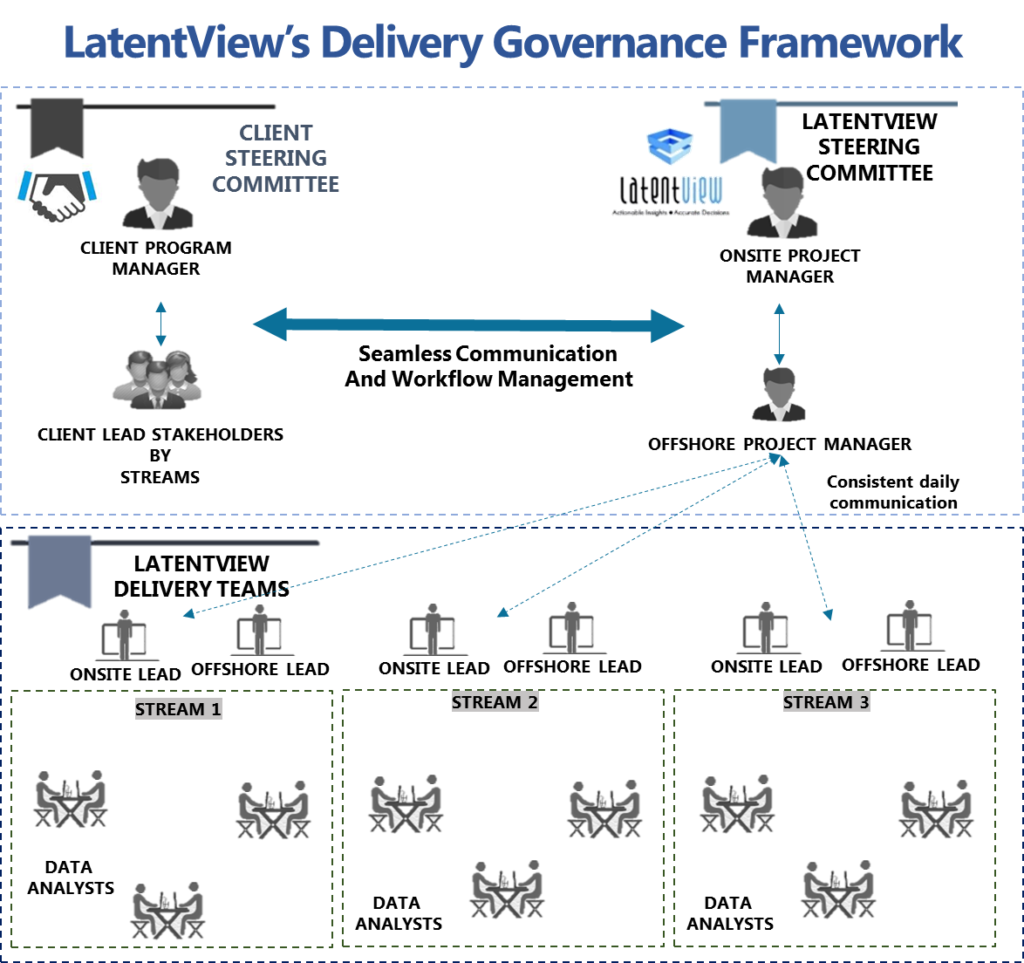

Figure 378: LatentView Delivery Governance Framework

For a CoE model to successfully cater for client’s delivery needs, LatentView has evolved processes and best practices which have served well even for teams of more than 120 members. At a broad level, LatentView’s approach focuses on the following guiding principles - a robust Governance Model, low onsite attrition, sufficient redundancy in the Resourcing Plan, Processes to enhance communication and finally metrics and processes to foster a continuous learning environment so that best practices can be easily and quickly replicated across different groups under the federated model. The following sections explain our approach and experience in greater detail.

**LatentView’s Best Practices for CoE Model**

#### Steering Committee

LatentView strongly believes that closely monitoring, capturing health metrics and sharing/receiving feedback with Client sponsor is extremely important for the engagement. To this end, our engagements under a federated model start with first forming a Steering Committee which manages and oversees the health of the engagement. Steering Committee would have the Client sponsor and Client leads from all streams from Client team side and Project Managers onsite & offshore from LatentView side.

#### Utilization Summary

Monitoring utilization is one of the key means to measure the health and efficiency of the federated model and hence this is a very important metric that is reviewed closely and frequently. All teams in LatentView record time sheets per resource which are then collated monthly and weekly to monitor utilization. In meetings with Steering Committee, Utilization figures are discussed, flagging low and high utilizations (across groups and all up) and monitoring overall monthly utilization to gauge the health of the delivery load for both client & LV stakeholders.

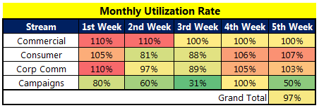

Figure 389: Representative Monthly Utilization Summary

#### Central Delivery Tracker

To give an all-up view of the overall delivery schedule, practices and processes across 120+ member team, LatentView adopts a Central Delivery Tracker which is meticulously and accurately filled as and when requirements come from various streams by project manager and leads. This is shared with the Client Steering Committee in the weekly meetings. This helps the Client   
Steering Committee to forecast demand and ration the delivery load in case of there is overload in particular stream to other less occupied streams. When there is expected demand spike in any one particular stream, the free resources in other stream would be easily assigned to help the stream to deliver and manage the demand spike. Below is a snapshot of a sample Central Delivery Tracker which is currently being used by LatentView.

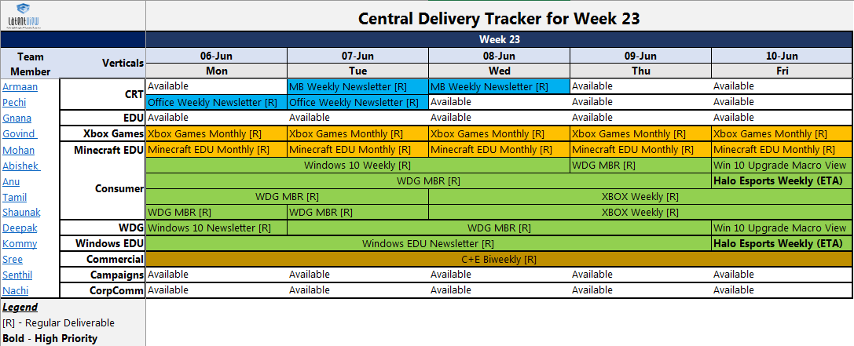

Figure 39: Central Delivery Tracker - Sample

The Central Delivery Tracker blocks all resources with assigned scheduled deliveries also identifying the available hours which can be utilized. All the client leads and sponsors are given access to the updated sheet maintained in SharePoint to enable individual stakeholders to manage and plan demand better.

#### Service Delivery Excellence Framework - Overview

LatentView’s Service Delivery Excellence (SDE) 2.0 framework is focused on improving delivery quality and enabling, continuous improvement. SDE 2.0 Framework specifies

1. Processes that will be followed in setting up a new project
2. Steps to be followed during the normal execution stage of the project
3. Delivery support tools that needs to be developed for the project
4. Metrics that will be used to measure the delivery service levels
5. Governance framework, that governs the SDE processes, including routine SDE processes, and issue or improvement handling processes.

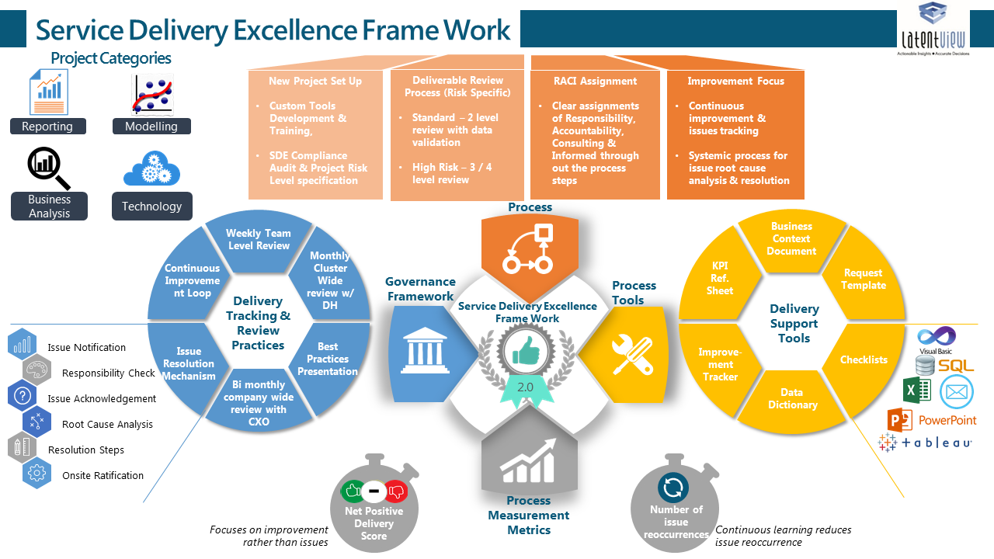

Figure 40: SDE Framework Overview

##### Project Setup

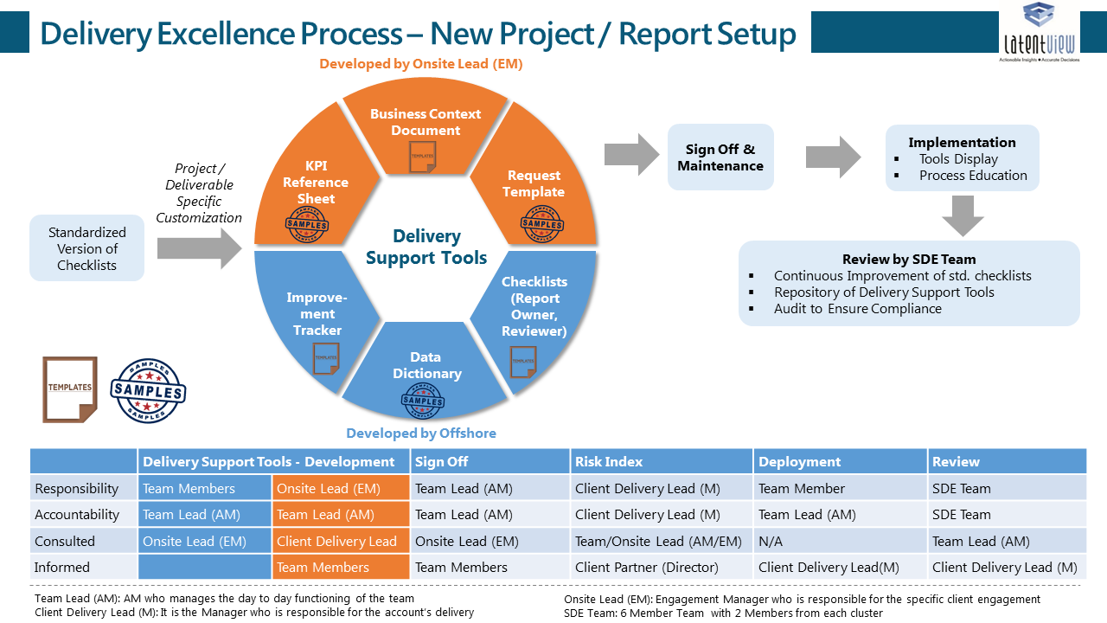

Figure 41: SDE Framework New Project Setup

#### Service Delivery Excellence Framework - Details

###### Project Operations

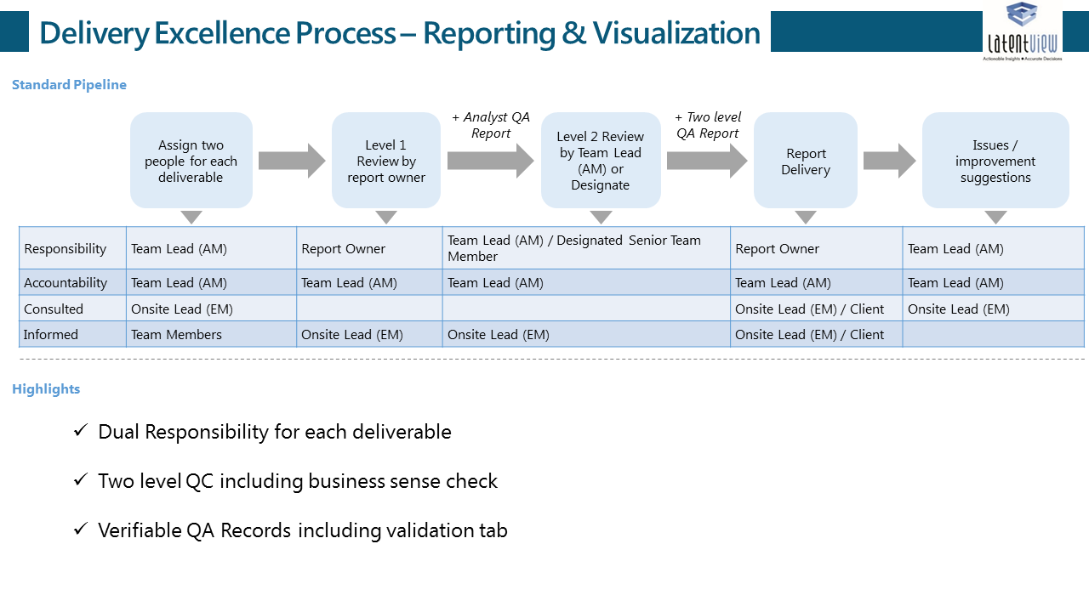

Figure 42: SDE Framework - Operations – A Reporting Project Illustration

###### Project Governance & Issue Handling

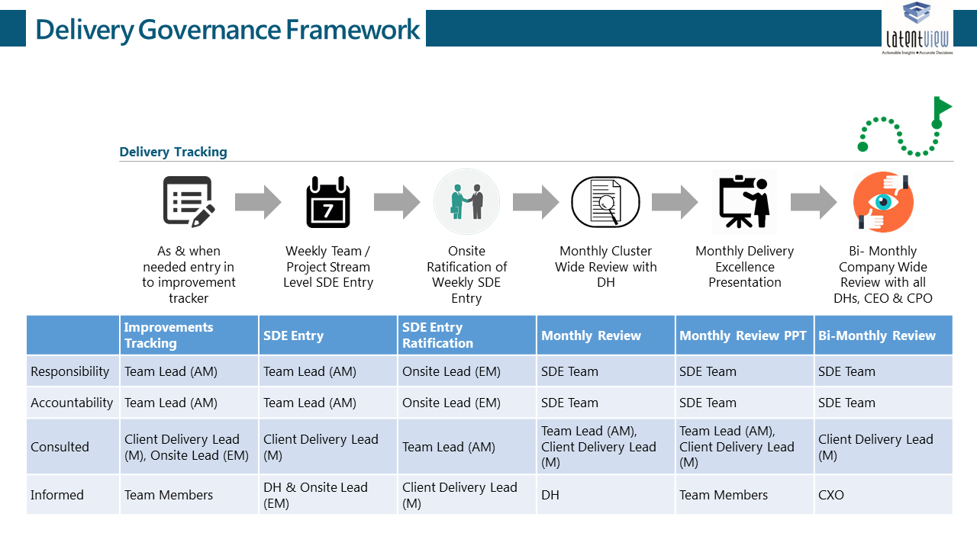

Figure 43: SDE Framework – Project Governance

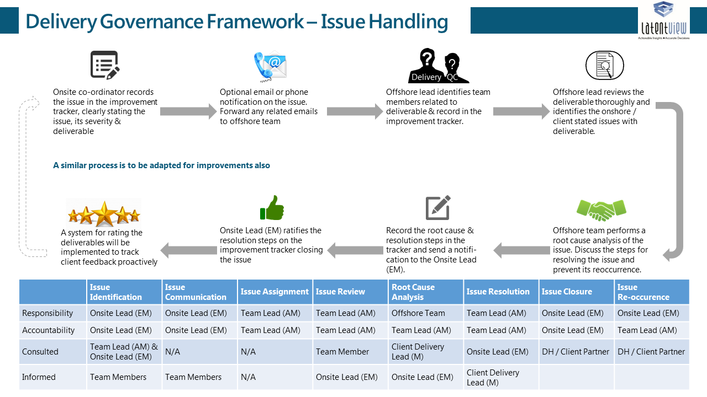

Figure 44: SDE Framework – Issue Handling

###### Project Communication

LatentView Analytics adopts seamless communication methods that will not only cover a regular cadence during testing phase but will also provide key insights and findings during production and learning phase to influence decision making.

The following communication strategy we will use at different stages of the Project:

* **Daily & Weekly Meetings:** LatentView encourages daily and weekly connect with Clients as per client’s convenience to give a progress update on the work done, have ad hoc and informal discussions.
* **PPIC** stands for **Progress, Planned, Insights and Constraints:** Both the past week’s progress and the subsequent week’s planned activities are reviewed. Process improvement and automation opportunities are identified and added to the pipeline. Innovations or interesting insights that came from the analyses for the week are highlighted. The final agenda item for the review is delivery constraints and solutions for the same. A continuous approach to PPIC Communications has led to meaningful improvements in delivery quality and communication with stakeholders.
* We can use **conference lines, video conferencing** such as join.me or go to meeting for Daily and weekly meetings.
* Our **onsite and offshore model** helps tremendously in proper and transparent communication.
* Onsite person always available to solve any constraint in the process, set up the meeting, arrange daily/weekly calls etc.
* Due to different time zone, overlap time is such that it is very easy to monitor results continuously and it reduces turnaround time as well.
* **Program Roadmap Review** will happen at monthly review meeting with leadership team and this can happen through video conferencing.
* **Monthly Business Review** is an all-hands meeting, owned by LatentView Analytics where the utilization and delivery health metrics for the prior month are shared with client leads. The monthly business review is to primarily gauge the health of the engagement.
* **Quarterly Business Reviews** would take place every three months with the Steering Committee with focus on following aspects:
* Reviewing the performance of the analytics support vs. goals
* Review the health and quality of the relationship
* Provide **strategic alignment** in the direction of the engagement by setting strategic goals for achievement
* Thought Leadership & Transformation road map discussions

The client-LatentView governance rhythm used for various engagements is working well and a similar routine is proposed for this solution as depicted in Table below.

|  |  |  |  |
| --- | --- | --- | --- |
| Name | Frequency | Description | Participants |
| Daily / Weekly Meetings | Daily / Weekly | Informal/Ad-hoc Discussions as per Client’s needs | Client Stakeholders & LatentView Analysts |
| PPIC | Weekly | Progress on the work done, Planned work, Insights uncovered & Constraints | Mail to Client Stakeholders by LatentView Analyst |
| Monthly Business Review | Monthly | Utilization Summary  Delivery across team summary  Review of operational performance  Review of key initiatives (e.g. strategic programs/projects) | Project Lead, LatentView Delivery Manager & LatentView Director-Client Services |
| Quarterly Business Review | Quarterly | Review of operational performance vs. SLA  Review of strategic programs vs. agreed goals  Present agreed strategic road map for upcoming quarter | Project Sponsor, Project Lead, LatentView Delivery Manager & LatentView Director-Client Services |

Table 2: Client - LatentView Governance Rhythm

* + 1. Knowledge Management Strategy
* LatentView has observed that the state of knowledge maturity can be achieved by systematically addressing the three pillars of Knowledge Management– **People:** people and culture; **Process:** process, policy, and strategy; **Technology:** technology and infrastructure in addition to continuously upgrading the maturity of KM to reach a state where it is embedded into the business processes. This is a path of continuous improvement and must be governed by a strong maturity framework, which has the ability to assess and benchmark the various aspects of People, Process and Technology in a holistic manner.

LatentView uses a multi-level knowledge management approach. This includes,

* Project/engagement level
* Corporate level

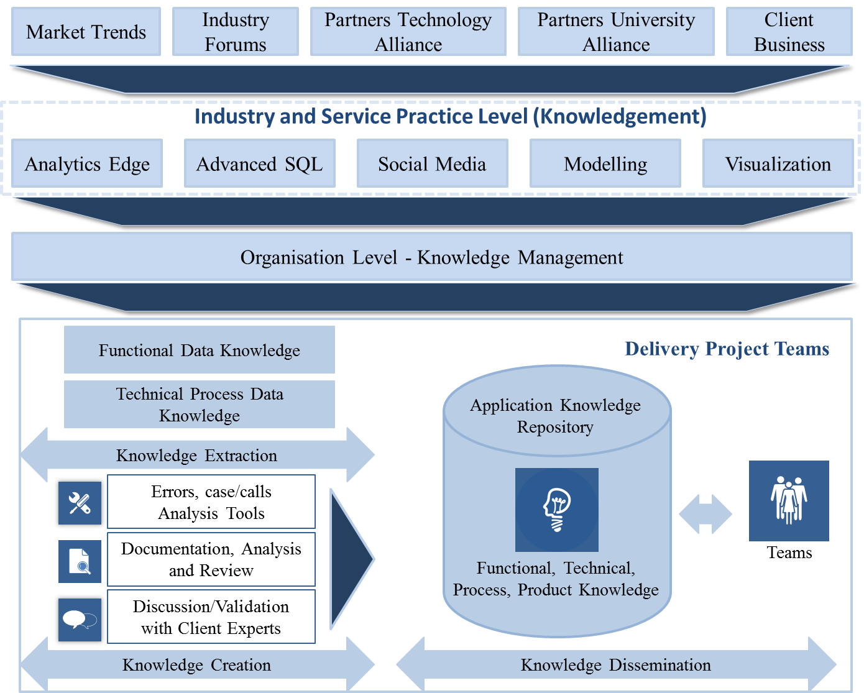

Figure 45: Managing Knowledge across Teams

1. Project/ Engagement Level

At the project level, the project plan template is created at the start of the project. The project plan serves as a reference document for project members and specifies document management requirements including configuration control. Projects also create their own electronic repositories with restricted access and security that provide a platform to store and utilize project-specific experiences, ideas, and so on. These details are also shared with the client, when requested.

In case of a relationship where multiple projects are being executed for a client, knowledge sharing occurs within these projects to enhance the ability of allocating resources between projects for that client.

Listed below is an example of the information that is stored for the execution of the projects

* Project Documents - Project Plan, Project Profile, Estimation Guidelines
* Project Reports - Status Report, Audit Report, Project Management Review Report, Metrics-related data
* Standards and Guidelines
* Checklists
* Templates - Transition Plan and the Induction Plan
* Team Member details
* Technical Documents
* Tools and Manuals
* General information about the project: client information, language, platforms, and so on.
* Sample project management data: scorecard, customer satisfaction survey reports, status reports, minutes of meetings within the relationship, and timesheet details

1. Corporate Level

* At the corporate level, knowledge dissemination includes sharing of best practices, white papers, functional /technical knowledge, and so on.
* Associates also share their knowledge/experiences on best practices, new technologies, and platforms and their functional knowledge through specifically organized knowledge sharing sessions.
* Knowledge sharing at the centre level is through the Process Assets database, where generic and authorized project information is stored. Information in the database includes PCI and ISO 27001 specified quality standards and guidelines, templates for plans, profiles and minutes, checklists, metrics to be collected, and performance levels maintained at the corporate level, generic technical documents, and so on.
  + 1. Knowledge Transfer & Documentation

LatentView will document the inputs, finalized ingestion and transformation parameters, constraints along all stages of the project and will provide detailed documentation to LEGO team that should enable them to independently run the data wrangling processes. We will also do a detailed discovery phase to understand the project requirements in detail and all such requirements will be captured in the requirements document. Client will be expected to sign off on the requirements document, prior to any process setup, modification or optimisation activity.

Our detailed documentation will include the technical architecture, ingestion parameters, refresh/update methodology, detailed list of metrics used, data dictionary, dependencies, detailed requirements document, process flow charts, functional module including algorithms used, documented codes, APIs information, test cases, demos, tool socialization content, and training videos. The document will also include a summary user guide for tool users and functional manual for advanced users / tool to manage the tool.

1. List of Documents Provided

* Requirements Document: All system / process requirements shall be documented after the requirements gathering phase
* Process Document: System level design and process specification shall be produced which will serve as the blueprint for the data wrangling optimization. This will contain two distinct parts.
* Functional Specification
* Technical Specification
* Verification/Test Protocols: Test cases shall be developed in parallel from the requirements by an independent team
* Requirements Traceability Matrix: Traceability matrix shall be maintained. This shall ensure the team to perform impact analysis on any change in the requirements in the future.
* RACI Matrix: RACI matrix shall be produced at the initial phase. This helps in identifying roles and responsibilities early in a project.

R- Responsible, A-Accountable, C- Consult, I-Inform

* User Guides: Shall be produced during the closing stages of the project.

1. Training

LatentView shall develop (in cooperation with the Project Team) a Knowledge Transfer and Training Plan to describe the approach for bringing managers, end users and technical personnel to a familiar level of understanding with how the new system works.

* + 1. Risk Management
* The following table shall be used as a guideline for initial risk planning. Risk identification shall be done at an individual module level (hardware, software etc.) and risk mitigation steps shall be put in place after the requirements stage.

| **Risk Description** | **Severity** | **Mitigation Plan** |
| --- | --- | --- |
| Environmental State (Software/Hardware/Network) | Medium | * Additional testing, particularly stress testing * Training on new environment * Get a prototype deployed ASAP on new environment |
| Team’s Experience (with environment/project size/scope) | Low | * Additional team training * Cross-training |
| Mid- Project change in scope | Low | * Add time to the schedule to allow for slippage |
| Limited Subject matter expertise on the business side | High | * Need to call out at the earliest from LatentView end and propose for a change in personnel |

Table 3: Risk Severity mapping - Illustrative

| **Risk Description** | **Probability** | **Mitigation Plan** |
| --- | --- | --- |
| **Pre-Transition Risks** | | |
| Delays in initial offshore set-up activities due to setup of communication infrastructure, software licensing etc. | High | LatentView to identify any offshore dependencies during the due-diligence, identify the lead time and jointly revise the transition plan accordingly |
| Delays in initial offshore set-up activities due to Security Authorization. | High | LatentView to identify any offshore dependencies during the due-diligence, identify the lead time and jointly revise the transition plan accordingly |
| **Risks related to Transition** | | |
| Lack of Documentation | High | Comprehensive study of the Business area during Knowledge Acquisition Phase with the help of Client |
| LatentView generally creates the necessary documentation for support as part of the transition |
| LatentView unable to absorb the key skills in time to enable offshore movement | Medium | All critical roles to be identified during due diligence. |
| LatentView to ensure rightly skilled resources are available. |
| Reporting mechanisms enhanced to cover the same. |
| Legal and Statutory Compliance Risk | High | Compliance to Enterprise wide ISO 27001 control |
| **Project related risks** | | |
| Project Size (Duration or Effort) | Medium | Decomposition (Break into smaller modules) |
| Phased implementation |
| Project Scope | Medium | Detailed specifications |
| Early prototype/review of functionality |
| Project Decision-Making | Medium | Specify decision-makers’ role in project documentation |
| **Risk related to Infrastructure & Security** | | |
| Delay in Infrastructure availability for LatentView team at Client sites | Low | Plan in advance for the required Infrastructure |
| LatentView tries to have regular communicate on a weekly basis with the Client Program |
| Dedicated Lead to oversee the infrastructure arrangements |

Table 4: Risk Probability mapping – Illustrative

1. Business Continuity and Disaster Recovery

* LatentView has robust Business Continuity and Disaster Recovery processes to ensure continuous undisrupted analytics and data operations for its clients.
* Chennai global delivery center is the operations hub for LatentView and has world class infrastructure. LatentView’s Business Continuity Management Team (BCMT), responds in accordance with Business continuity plan and initiates specific actions for recovery in the event of a disaster.
* The primary team members of BCMT are Director IT, Delivery Manager and Director HR/Admin. Periodic back up of is carried out as a precautionary step in BCP.
* LatentView uses WINDOWS® backup application to store backed-up data in multiple server locations. The primary and secondary domain controllers for active directory are implemented to avoid single point of failure.
* LatentView also has satellite office relationships with other locations across South India (Coimbatore, Bangalore, and Kochi), where our staff could be relocated for a short duration and operations aren’t affected.
* **Highlight to the Business Continuity** was the recent floods at Chennai where multiple IT firms, BPO firms and even several client’s Indian offices experienced loss in operations and delivery. However, our client’s senior leadership commented that our business continuity processes ensure that we communicated well in advance, ensured that there was only minimal loss of productivity and that we were able to respond much better to the calamity than other teams they were associated with.
  + 1. Quality Assurance

LatentView will develop and implement a Quality Management Plan to ensure quality across the program. The following are taken into consideration while preparing the Quality Plan document.

 The criteria that will be used to assess quality

* The attributes that will be incorporated into the management and the delivery of the program
* The team responsible for carrying out these activities
* How the program will meet required audit and organizational standards for quality assurance and quality control

The activities performed under quality management are:

* Quality assurance and output reviews
* Quality management of governance activities including
* Adherence to organizational and industry standards
* The consultation and engagement of stakeholders
* Appropriate design and implementation of good practices in quality management and delivery

Assurance reviews will be carried out by peer groups or other individuals from parts of the organization. Each of the assurance reviews will have a clear brief. It will be carried out at any time during the program, and will be repeated in areas where problems were identified, and recommendations made for improvements.

 The assurance methods will focus on:

* Quality management assurance – assessing the implementation and performance of the program, referring to the quality management strategy
* Business assurance – assessing the management of the business case and continued viability of the program against it
* Stakeholder assurance – assessing the mechanisms and the performance of the stakeholder management arrangements

LatentView uses the **DARTS** **framework** for this quality assurance. The model covers five essential criteria namely:

* **Documentation:** LatentView follows an agreed upon documentation process that helps us to follow up with the status of projects every week, to track down the number of incidents raised and enhancements identified with appropriate naming conventions. Internal audit team audits these documents monthly and measures the overall performance metrics of the projects
* **Accuracy**: LatentView documents all accuracy/error related incidents raised by different stakeholders and use the same to measure accuracy for each project
* **Responsiveness**: This is measured based on LatentView’s response to any client request within an agreed upon time mutually decided by the client and LatentView
* **Timeliness**: This is measured against the actual completion date as mentioned on SOW
* **Satisfaction**: LatentView use Quarterly survey to track the level of customer satisfaction on a scale of 1 to 10, with 1 being “Completely Dissatisfied” and 10 being “Completely Satisfied”. Combining the scores of all parameters of this satisfaction survey, a consolidated score for customer satisfaction is calculated.

Above mentioned criteria are analyzed in two ways. First, LatentView conducts internal audits and second, LatentView takes surveys from clients as well. Based on these two aspects, the dimensions are specifically analyzed and compared with the benchmarks defined for each criteria. Then individual scores are calculated for these criteria which help us to identify the areas of further improvement.

|  |  |  |
| --- | --- | --- |
| **Dimension** | **How is it Measured?** | **Benchmark Score  (on a scale of 10)** |
| Documentation | 1. Documents refreshed weekly 2. Audited monthly | 9 |
| Accuracy | 1. Accuracy related incidents/emails from stakeholders 2. Monthly Internal Audit + Client survey | 9.5 |
| Responsiveness | 1. Responses to client requests tracked 2. Monthly Internal Audit + Client survey | 9 |
| Timeliness | 1. Measured against actual completion date in SOW 2. Monthly Internal Audit + Client survey | 9 |
| Satisfaction | 1. Monthly Internal Audit + Client survey | 8.75 |

* 1. Data Security & GDPR

Information is an extremely valuable and important corporate asset that requires protection against risks that would threaten its confidentiality, integrity and/or availability. LatentView is engaged in delivering business critical insights by analysing customer data. In such a business, information security is an essential prerequisite for customer confidence. Suitable information security controls must therefore be selected and implemented. The security controls identified in LatentView’s policy are based on ISO standards 27001.

LatentView has a stringent data security policy to ensure clients confidentiality, the key elements of which are as follows:

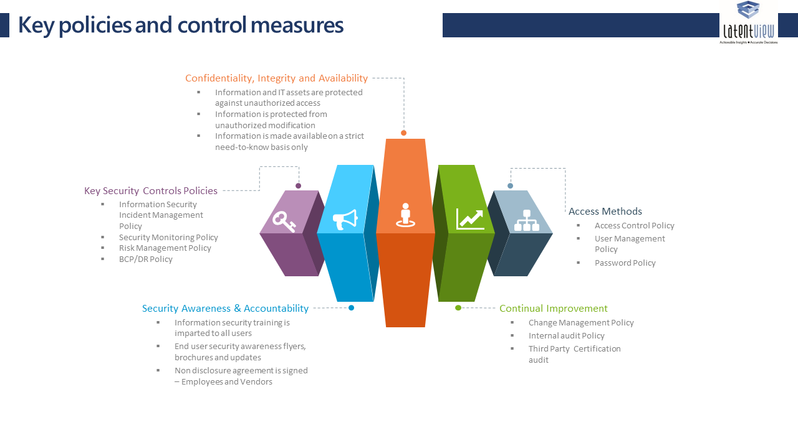

Figure 46: Key elements of data security policy

**The above features of data security are enabled by LatentView using the following infrastructure and processes**

**Infrastructure and Data Security:**

LatentView has a secure data center and powerful computing servers for our analytics practices. LatentView has taken extensive measures in maintaining the security standards and is certified as ISO 27001 and PCI (Payment Card Industry Standard) complaint organization.

**Centralized Cloud Infrastructure:**

LatentView uses the Amazon cloud system for computing intensive processes that require faster results.

**Physical Security Standards:**

Physical security of the site is ensured by 7x24x365 guards. Biometric finger print is used to have secure authorized entry to our premises. Cameras are placed throughout the perimeter with guards and recorded video is maintained for 30 day periods on all cameras. All access is logged and tracked. Smoke detectors are used, as is laser air sampling. Conventional smoke and heat sensors are cross-zoned throughout the ceiling and below the raised flooring.

**Data Security and Backup**: Storage Area Network (SAN) is used to store our data. Daily, incremental and complete backups are taken in disk-to-disk backup processes executed to external disks. Backup devices are stored in a secure environment and are available for immediate restore.

* + 1. Data Security Policy - Detailed

LatentView’s policy guidelines are designed to preserve the confidentiality, integrity, availability, and value of all information assets, as well as to ensure the continued delivery of business services. They also establish the appropriate focus and standards for acceptable information security practices across the organization. This policy is based on applicable regulations and highlights Customer goals and requirements for protecting its information assets.

LatentView aims to promote and build an environment where all employees are aware of their individual information security responsibilities and are actively engaged and committed to improving standards of information security.

LatentView shall implement appropriate security controls to ensure that:

i) Information assets are identified and categorised in terms of business value.

ii) Ownership of information assets is established and responsibilities defined.

iii) Information and IT assets are protected against unauthorized access.

iv) Information is made available on a strict need-to-know basis only.

v) Information is not disclosed to unauthorized persons through deliberate or careless action.

vi) Confidentiality of information is assured in accordance with client agreements and best practices.

vii) Information is protected from unauthorized modification.

viii) Applicable regulatory and legislative requirements are met.

ix) Disaster recovery plans for IT assets are developed, maintained and tested.

x) Information security training is imparted to all users of information assets.

xi) Information security breaches are reported, investigated, resolved, and closed.

xii) A culture of compliance towards information security is advocated and promoted.

xiii) Violations of policies are dealt with disciplinary action.

xiv) The responsibility for maintaining the policy and providing advice and guidance on its implementation rests with LatentView management.

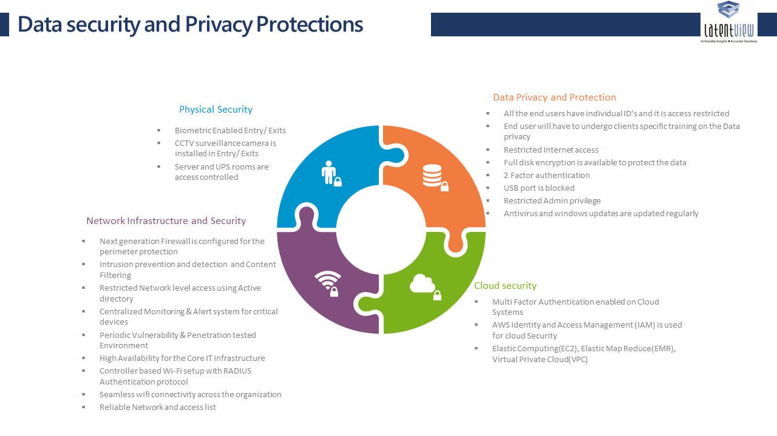

Figure 47: Data Security Policy Aspects

* + 1. GDPR

LatentView typically performs the role of a data processor for our clients and adhere to the following GDPR guidelines



Typically for certain client engagements involving data engineering, LatentView assumes the role of a controller according to GDPR guidelines and follows those guidelines in addition to the processor guidelines



* + 1. Security Certifications

Below are the security certifications, LatentView have undergone through.



**Network Redundancy**: Networking to the analytics platform is ensured by having high speed Internet Leased Lines. Alternate carrier capabilities are also present. SonicWALL firewall secure SSL VPN is used to connect a fully meshed networking fabric to each LatentView site. Sys Logs are stored and reviewed for violations and/or suspicious activity. Port activity is carefully monitored and opened only on a needs basis. Network Security Appliances at the perimeter level enables us with many security features that are tamperproof.

**Security in Data Transfer / Access**: A dedicated FTP server in AWS is being used for file transfers and McAfee is used for encryption. All client data is maintained within the analytics infrastructure and off-shore teams log into the platform via secured VPN, authenticate to the domain and then sign into the specific server and project. Permissions are limited to the key project members and align with the functions they are performing. System logs are reviewed for access patterns, violations or suspicious activity.

**LatentView HIPAA Certification**

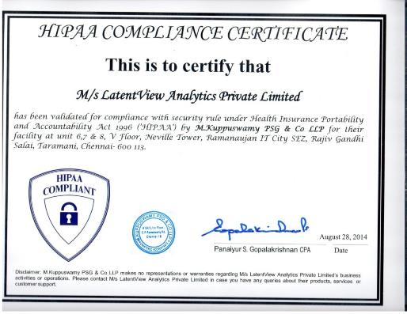

* + 1. Security Training

LatentView employees are put through information security training upon their induction in to the company and at periodic instances after that. For employees working in specific client projects, they also undergo the security training and evaluation as prescribed by the client.

Employees and delivery managers working on Europe based client engagements are additionally put through GDPR training done by external agencies.

* + 1. References

LatentView’s data security policy incorporates the following elements from global information standards

|  |
| --- |
| LV-ISMS-PO-02 Security Organization Policy |
| LV-ISMS-PO-03 Asset Management Policy |
| LV-ISMS-PO-04 Information Security Incident Management Policy |
| LV-ISMS-PO-05 Compliance Policy |
| LV-ISMS-PO-06 Acceptable Usage Policy |
| LV-ISMS-PO-07 Change Management Policy |
| LV-ISMS-PO-08 Communication Policy |
| LV-ISMS-PO-09 Clear Desk and Clear Screen Policy |
| LV-ISMS-PO-10 BCP-DR Policy |
| LV-ISMS-PO-11 Access Control Policy |
| LV-ISMS-PO-12 Password Policy |
| LV-ISMS-PO-13 Information systems Acquisition Development Policy |
| LV-ISMS-PO-14 Email Policy |
| LV-ISMS-PO-15 Malicious Code Policy |
| LV-ISMS-PO-16 Mobile Computing Devices Handling Policy |
| LV-ISMS-PO-17 Internet Policy |
| LV-ISMS-PO-18 Physical and Environmental Control Policy |
| LV-ISMS-PO-19 Data Protection and Privacy policy |
| LV-ISMS-PO-20 Backup Policy |
| LV-ISMS-PO-21 User Management Policy |
| LV-ISMS-PO-22 Measurement of Effectiveness of Control Policy |
| LV-ISMS-PO-23 Risk Management Policy |
| LV-ISMS-PO-24 Internal Audit Policy |
| LV-ISMS-PO-25 Network Policy |
| LV-ISMS-PO-26 Server Security Policy |
| LV-ISMS-PO-27 Patch Management Policy |
| LV-ISMS-PO-28 Security Monitoring Policy |
| LV-ISMS-PO-29 Cryptographic Policy |
| LV-ISMS-PO-30 Outsourcing and External Facilities Management Policy |
| LV-ISMS-PO-31 Purchasing Policy |
| LV-ISMS-PO-32 Human Resource Policy |
| LV-ISMS-PO-33 Policy For interested Parties |
| LV-ISMS-PO-34 SDLC Policy |
| LV-ISMS-PO-35 System Security Testing for Fulfilling Security Requirements Of Application Policy |
| LV-ISMS-PO-36 Wi-Fi Policy |
| LV-ISMS-PO-37 Capacity Management policy |

* + 1. Experience in Devloping Systems with GDPR Compliance

One of our clients, a global financial payment gateway provider with operations in US, UK and APAC, we developed an analytics application on Hadoop platform. The client has very strict policies towards data security. Following are the set of best practices which helped us to achieve this:

* Access to client resources: Only client authorized team members can access the client data. No sharing of data without getting client approval. Off-shore teams log into the platform via secured VPN and then sign into the specific server and project. Permissions align with the functions performed by the team members.
* Security Certifications: LatentView has ISO 27001 and PCI-DSS(Payment Card Industry Standard) Certifications.
* Physical Security Standards: Physical security of the site is ensured by 7x24x365 guards with Biometric authentication and video monitored. All access is logged and tracked.
* Client Specific Security Measures: Any addition/deletion of a resource is intimated to the client immediately and all access to data is restricted immediately upon removal
  1. Key clients supported & powered by LatentView`s Analytics services

|  |  |
| --- | --- |
| LatentView Client | Services Provided |
|  | LatentView has set up a large team to support various teams of **Microsoft** such as Central Marketing Group, Social Intelligence Team, Products Group, etc. Our platform supports functions such as Feature Innovation, Consumer Insights, Competitive Intelligence, Campaign Analytics & Path to Purchase. LatentView supports Microsoft`s marketing function since 2012 |
| Image result for paypal logo transparent | Over a 7-year partnership LatentView has become the innovative and trustworthy partner for Paypal by supporting on the entire spectrum of analytics services in the areas of Marketing, Finance, Products and Web Analytics |
|  | **PepsiCo**`s Digital marketing function is exclusively supported by LatentView`s solution since 2013. Some of the key areas include Digital metrics, Marketing Mix & RoI, Campaign Analytics, Product Innovation & New Product Development, Market/Product Launches. |

Table 1: LatentView Key Clients and Analytics Solutions